

**THE EGYPTIAN E-LEARNING UNIVERSITY**

**Faculty of Computers and Information**

**Technology ( IT )**

**Graduation project: Career Guidance**

**BY**

* + **Mohamed Khaled Abdeltawab (Team Leader)**
  + **Abdelrahman Maged Abdeldayem**
  + **Abdelrahman Rezk Mohamed**
  + **Ziad Elamir Mohamed**
  + **Shrouk Ahmed Rashad**
  + **Nourhan Khaled Shipa**
  + **Rania Rabie Sayed**

**Supervised by**

**Eng. Ahmed Gomaa**

**2024-2025**

***Table of content***

**1-Introduction**……………………………………………………………………………………………

**2-Problem** ………………………………………………………………………………………………….

**3-Chapter One**……………………………………………………………………………………………..

**-** Detailed Explanation…………………………………….…………………………………………

4-**Chapter Two**

-Pages (Dark and Light Mode)………………… ……………………………………………….

4.1-Sign-up…………………………………………… ………………………………

4.2-Login…………………………………………………………………………………………..

4.3-Dashboard …………………………………………………………………………………

4.4-Roadmaps {for All Roadmaps} …………………………………………………….

4.5-Roadmap {for Specific Roadmap} ………………………………………………...

**5-Chapter Three**………………………………….………………………………………………………..

5.1-Sequence………………………………………………………………………………………………..

-Sign Up………………………………………………………………………………………………….

-Login……………………………………………………………………………………………………..

5.2-Use Case…………………………………………………………………………………………………

5.3-User Story……………………………………………………………………………………………….

-Login, Sign Up…………………………………………………………………………………………..

-Admin Dashboard…………………………………………………………………………………….

-Roadmap………………………………………………………………………………………………….

6.Chapter Four…………………………………………………………………………….

-Tools……………………………………………………………………………………………………….

-Dependences…………………………………………………………………………………………..

***Introduction***

* The field of programming has become one of the most popular fields in the world, and anyone, regardless of their qualifications, can enter it. This field is one of the fields in which a person can learn individually through the huge amount of resources available on the Internet.

***Problem***

* When starting in programming or college, many people find it hard to choose the right path, which can cause frustration and wasted time. The main problem is that they don’t have a clear idea of the different programming tracks available. Without the right guidance, they might depend on advice from others that may be biased, or try to learn everything at once, which can be overwhelming and not effective. Choosing the right track is important for learning efficiently and achieving success in the field.

***project idea(Solution)***

* Career Guidance, a guidance platform designed to help anyone looking to enter the programming field by providing comprehensive information tailored to their chosen path. Based on the platform’s resources, users can access a variety of courses, each accompanied by relevant links and general information about different paths. Additionally, we provide detailed roadmaps for all available paths in the job market, explaining how to learn each one and where to find the necessary resources. All of this is readily available on our platform, ensuring that users have everything they need to successfully navigate their programming career.

Chapter one

***Detailed Explanation***

**Career Guidance: Simplifying Your Journey into Programming**

The Career Guidance project is designed to help individuals, particularly those interested in programming or transitioning to a tech career, navigate the overwhelming choices in the field. This project is targeted at students, recent graduates, and professionals who want to make an informed decision about their career path in programming. Here's a clear breakdown of the project’s key features and purpose.

**Challenges in Exploring Programming Fields**

When someone starts exploring programming, they often feel lost or unsure of where to begin. Whether they are new college students or professionals looking to shift their careers, it's common to receive advice that only promotes a single field—often from someone already working in it. This advice can limit their perspective, pushing them toward a specific path, which may not even be the right one for them.

For example, if they hear about a field like Embedded Systems without fully understanding it, they might miss out on discovering whether it's a good fit for them. The same goes for spending time exploring various courses or resources online, often wasting valuable time without achieving any real results. Many people are stuck in this cycle, unsure of what programming field to choose or how to efficiently start learning.

**What Career Guidance Offers**

This is where Career Guidance steps in. We are here to assist anyone interested in tech or programming, especially those who have been trying hard but haven’t seen tangible progress. Our platform provides users with:

* **An Overview of All Available Fields:** We offer insights into various programming tracks and explain each one in detail—what it involves, its demand in the market, and whether companies are still actively using those technologies.
* **Tailored Roadmaps for Every Track:** After helping users gain a clear understanding of different fields, we guide them to select the track that suits their interests. We provide personalized roadmaps that show a structured and organized learning path, complete with recommended courses and resources.
* **Course Recommendations:** Based on whether the user is a beginner or has some prior knowledge, we suggest the best courses to kickstart or further their journey. These courses have been carefully curated, tested, and organized based on real-world experience to ensure users learn in the most efficient way.
* **Real-time Progress Tracking:** Our system allows users to track their learning progress in real-time, with features like a progress bar showing them exactly how much they’ve completed and what's still ahead.

**Additional Support and Features**

* **CV Building:** We help users craft strong CVs tailored to their chosen track, increasing their chances of landing a job.
* **Job Opportunities:** Based on the user’s learning track, we recommend job opportunities that align with their new skills.
* **Affordable Premium Courses**: We offer paid courses at a lower price than elsewhere, helping users gain access to quality learning materials at a budget-friendly rate.
* **Customization**: Users can choose between dark mode and light mode for a comfortable experience.
* **Quizzes and Checkpoints:** Each stage of the roadmap includes quizzes to ensure that the learner has fully grasped the concepts before moving forward. This helps build confidence that they are ready for the next phase.
* **Detailed Explanations of Every Track:** Before diving into any programming track, users can explore commonly asked questions, details about the programming languages they'll learn, and the frameworks they'll use—so there's no confusion about what they're getting into.

**Target Audience**

Our project caters to all age groups but is particularly focused on people between the ages of 18 and 40, who are either starting their journey into tech or looking to make a career change.

**In Summary**

Career Guidance simplifies the process of finding the right programming path by offering personalized, structured guidance, real-time tracking, and support at every step. By helping individuals choose wisely and learn effectively, we ensure they can start their careers in tech without wasting time or effort, all while staying engaged and motivated throughout their journey.

Chapter Two

Diagrams

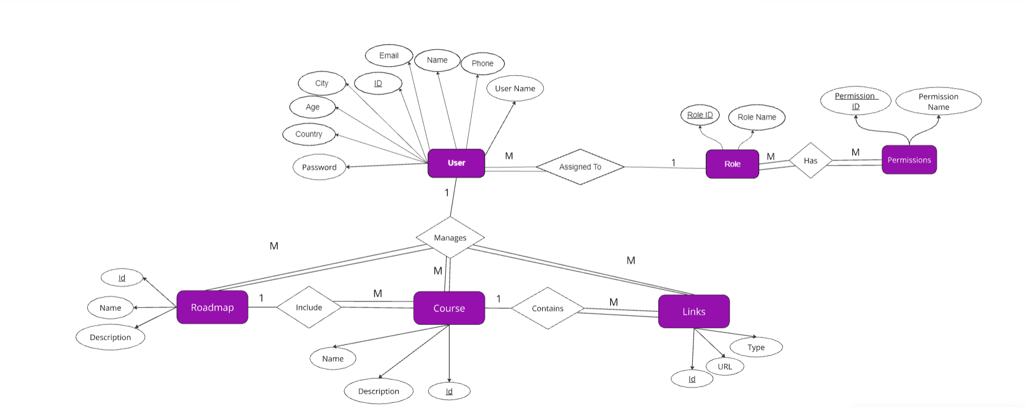

Figure 1:ERD DIAGRAM

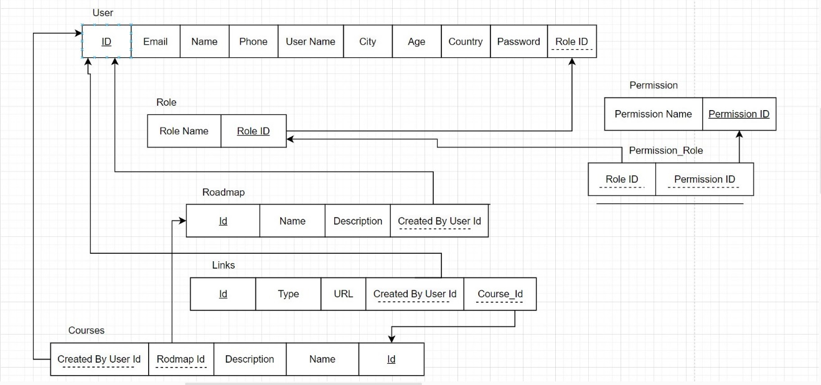

Figure 2:Schema

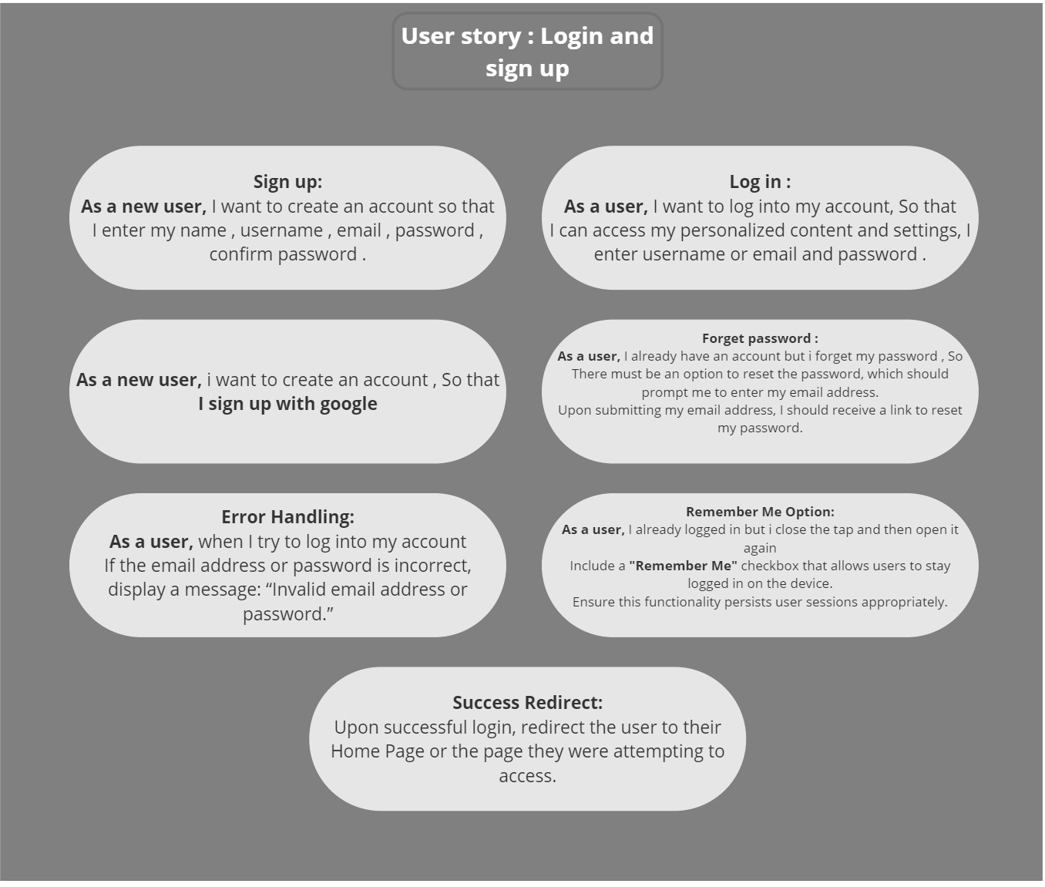

Figure 3:(User Story) Login and Sign Up

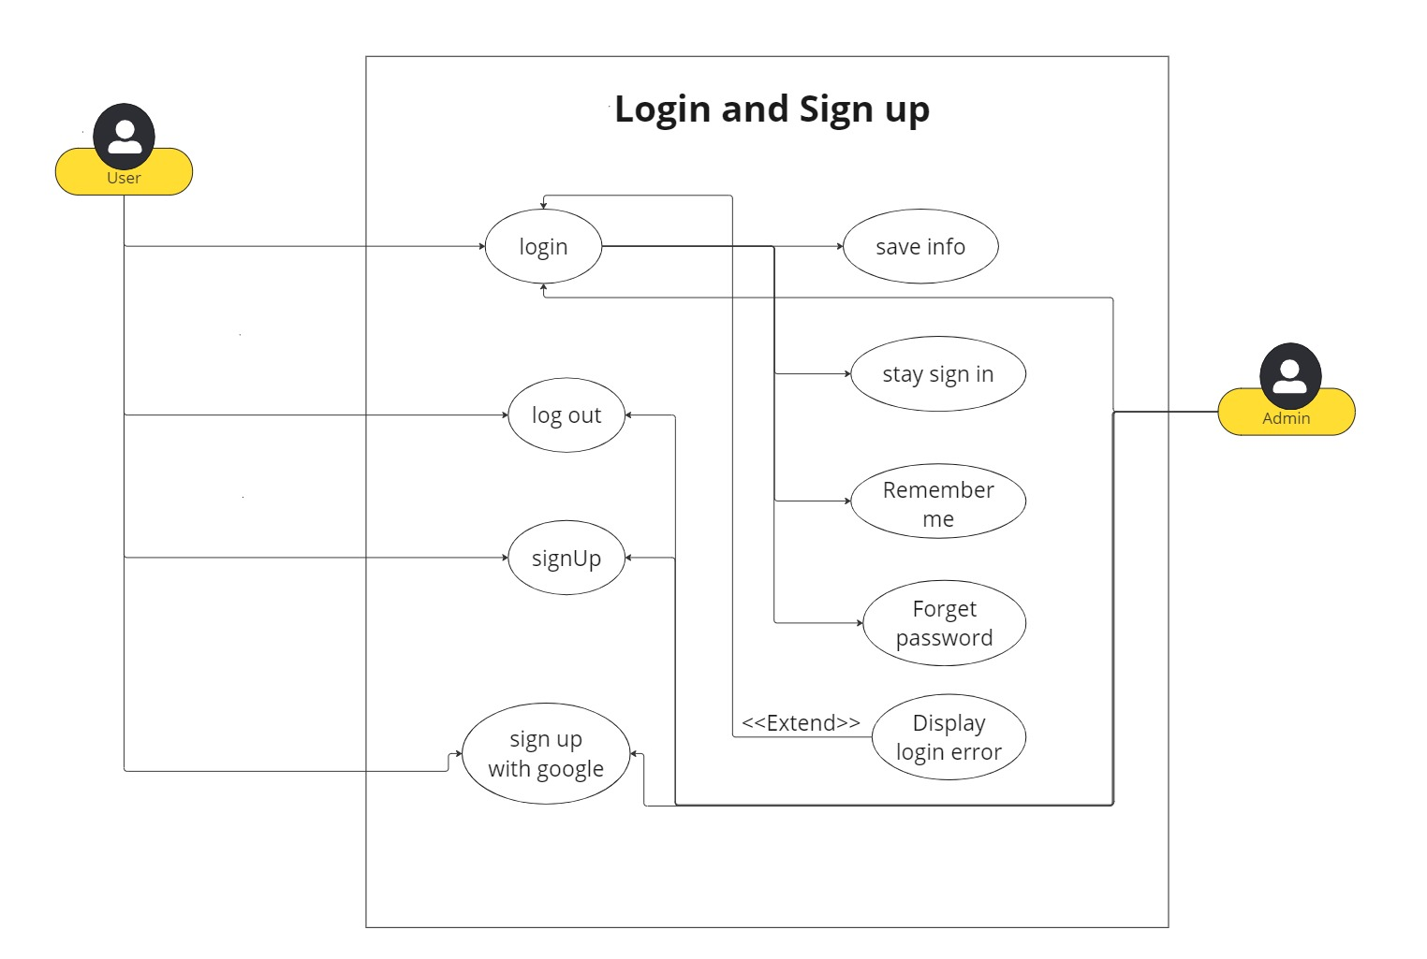

Figure 4:(Use Case) Login and Sign Up

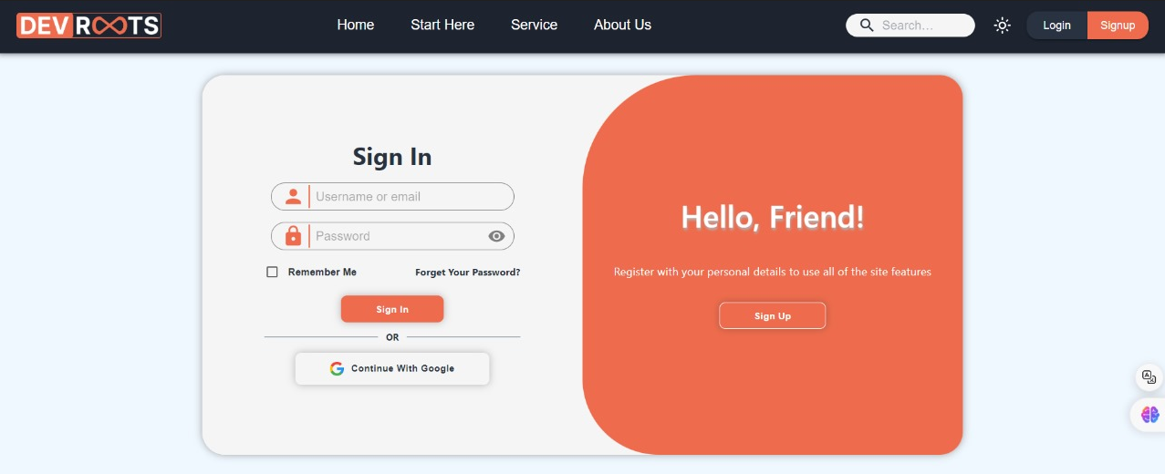

Figure 5: Login Light Mode (UI)

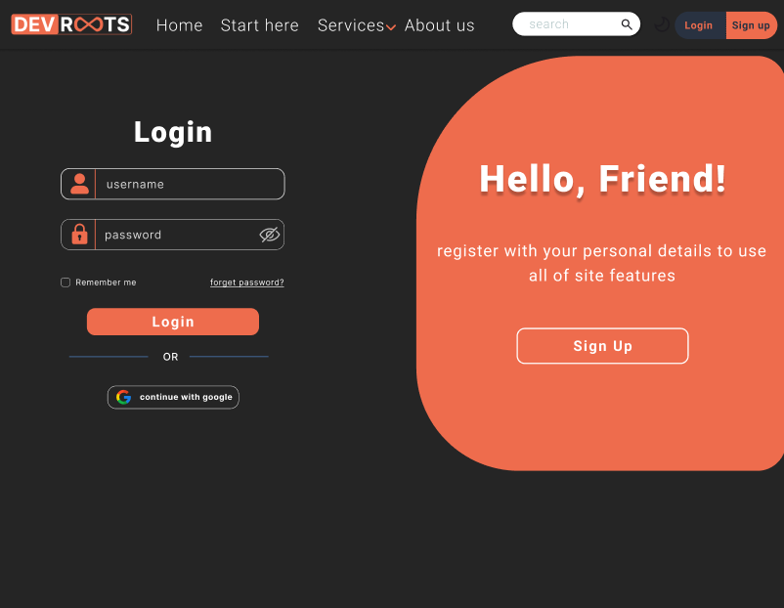

Figure 6:Login Dark Mode (UI)

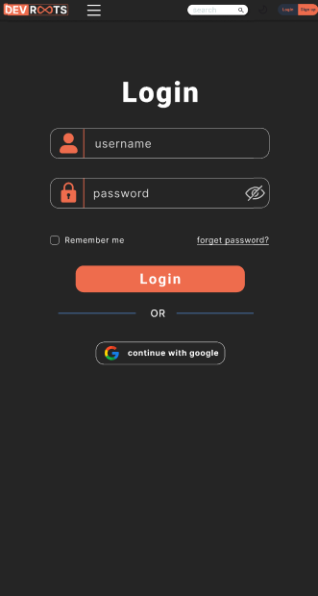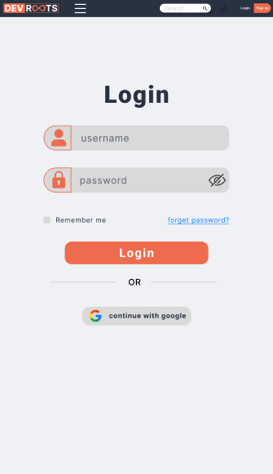

Figure 7:Login Dark and Light Mode For Phone (UI)

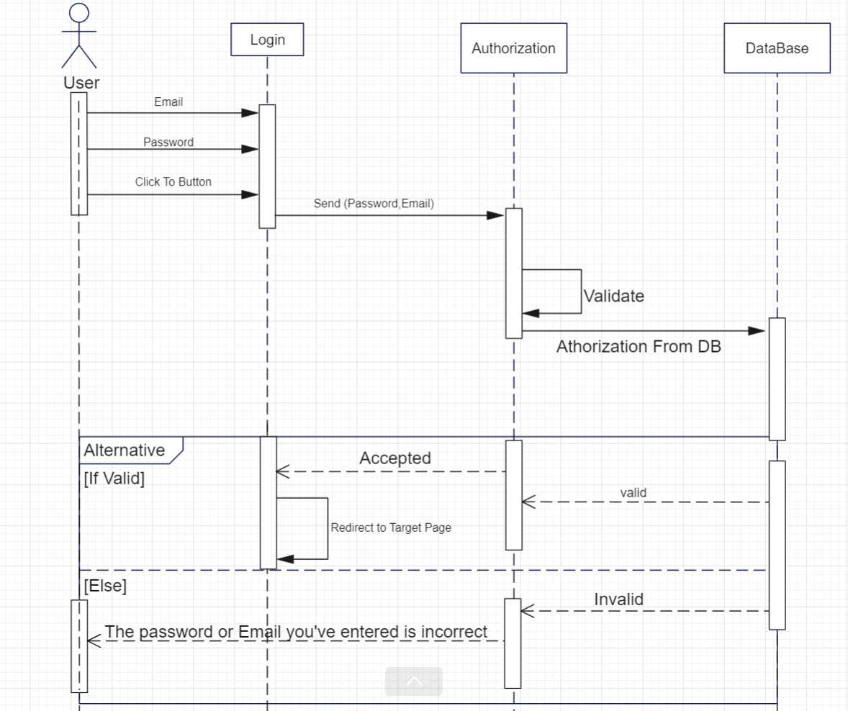

Figure 8: Sequence Diagram For Login

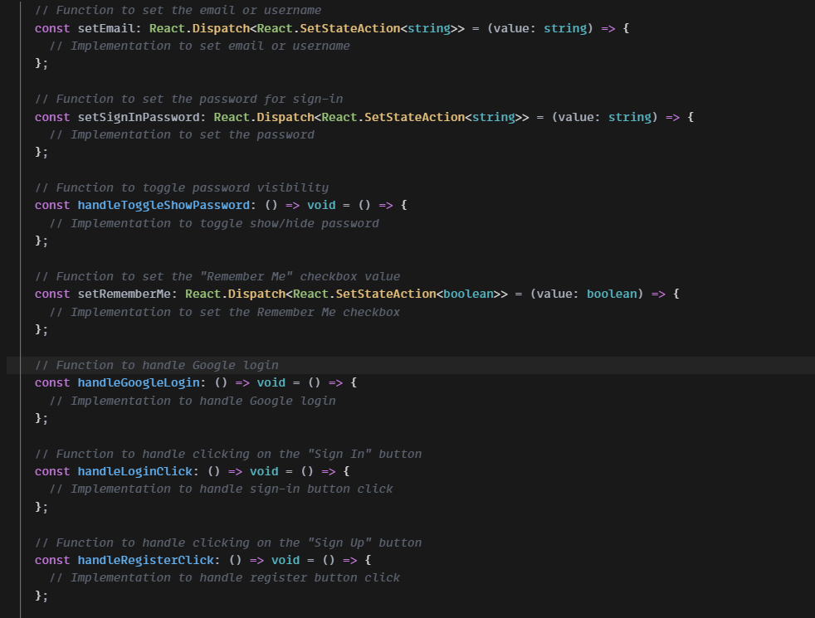

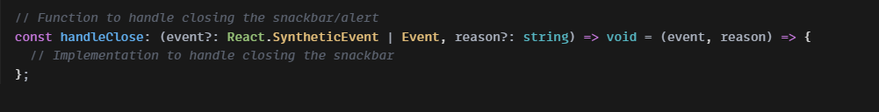

Figure 9: Login Design Code(Frontend)

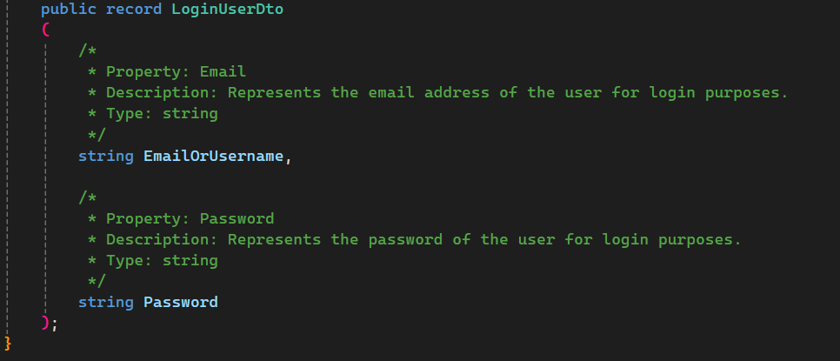

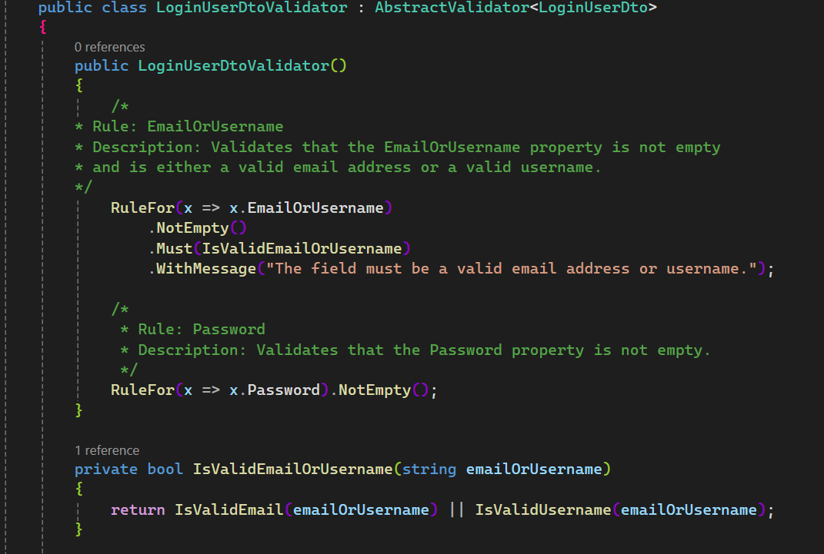

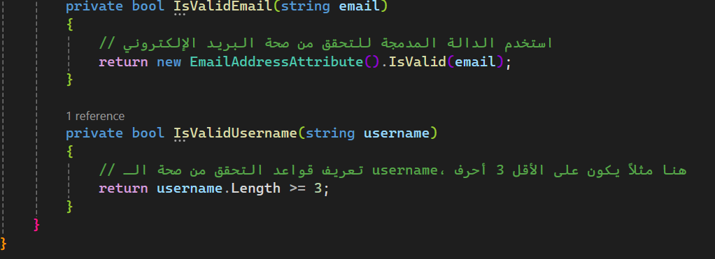

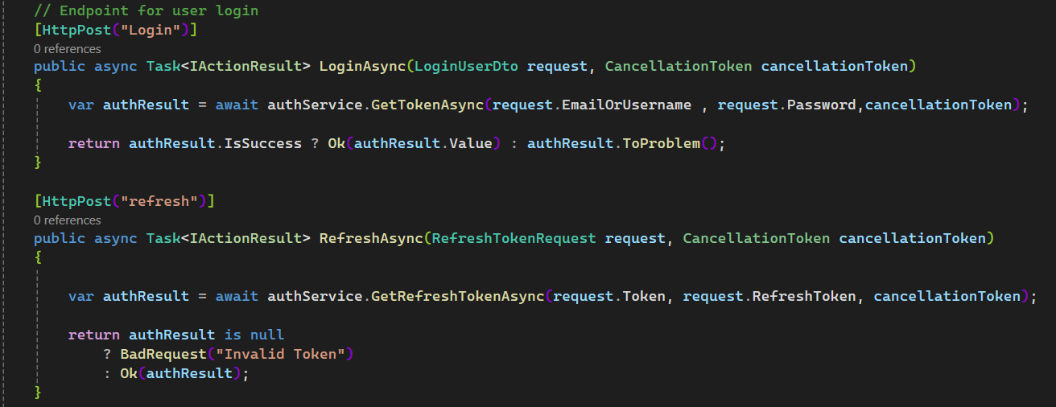

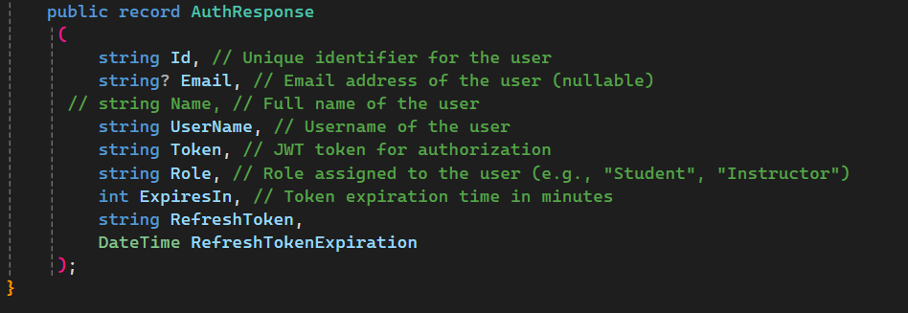

Figure 10:Login Design Code(Backend)

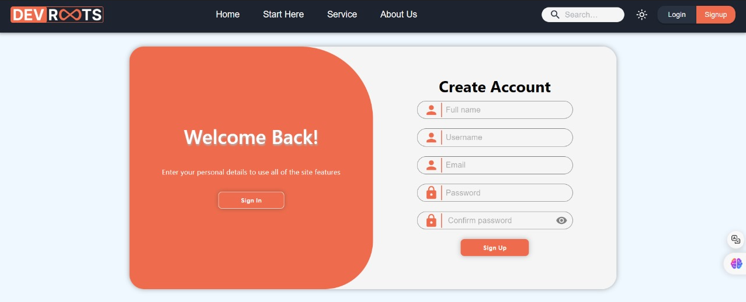

Figure 11:Sign Up Light Mode (UI)

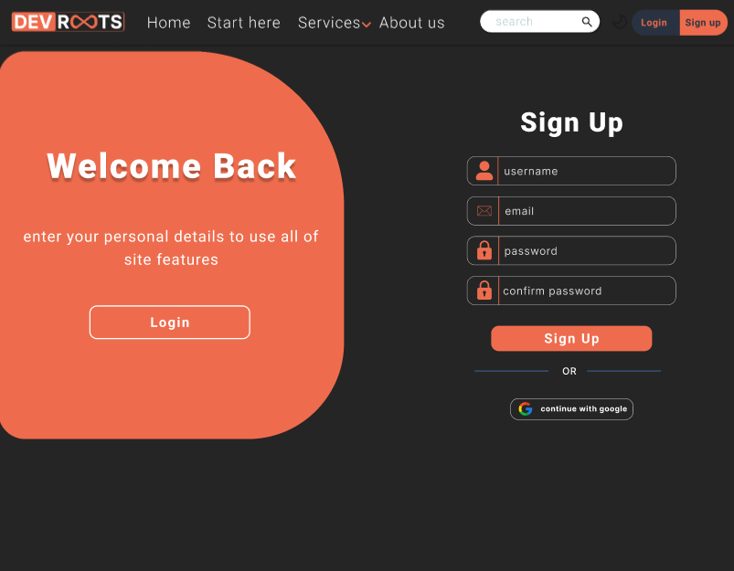

Figure 12:Sign Up Dark Mode (UI)

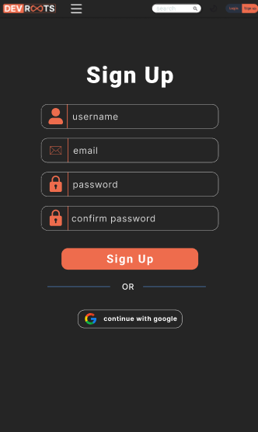 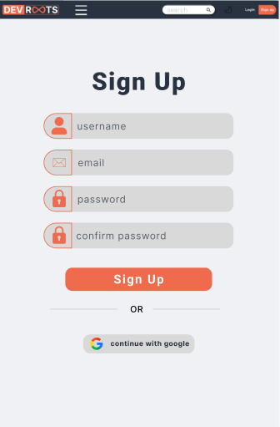

Figure 13:Sign Up Dark and Light Mode For Phone (UI)

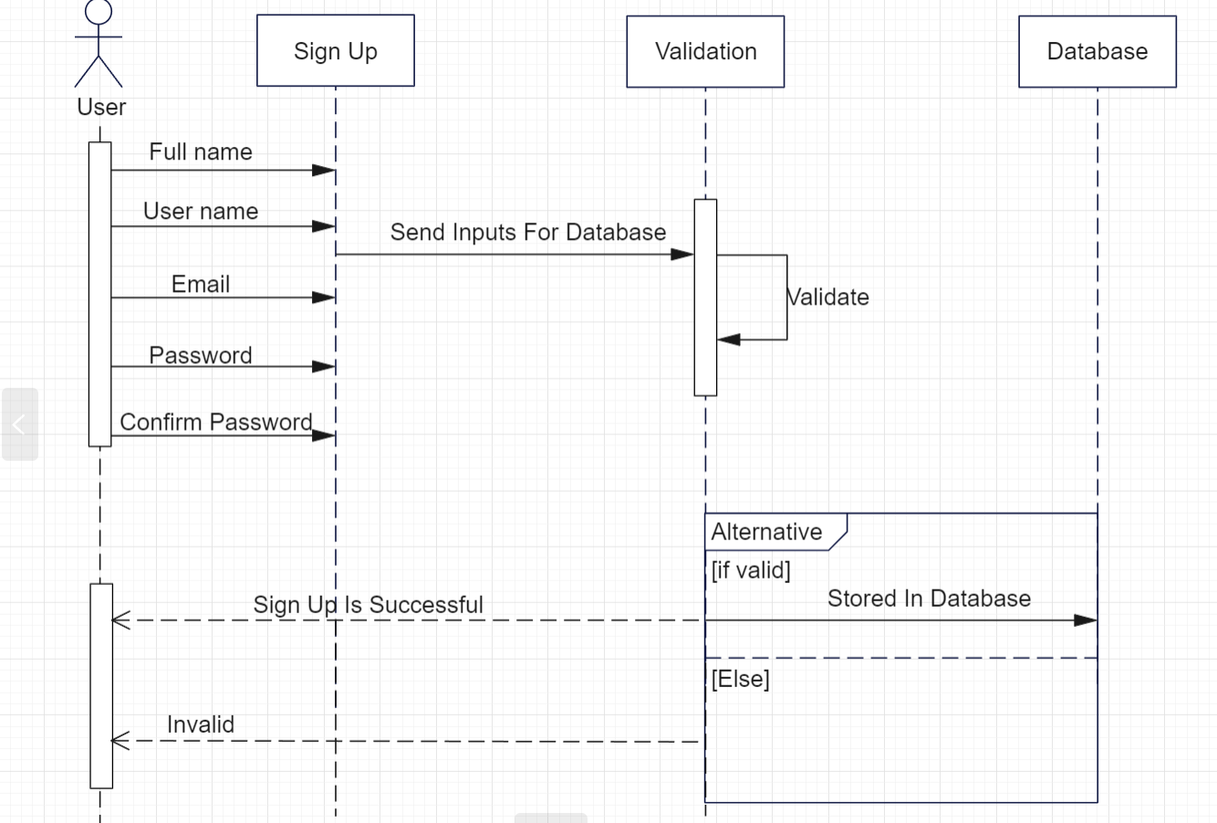

Figure 14:Sequence Diagram For Sign Up

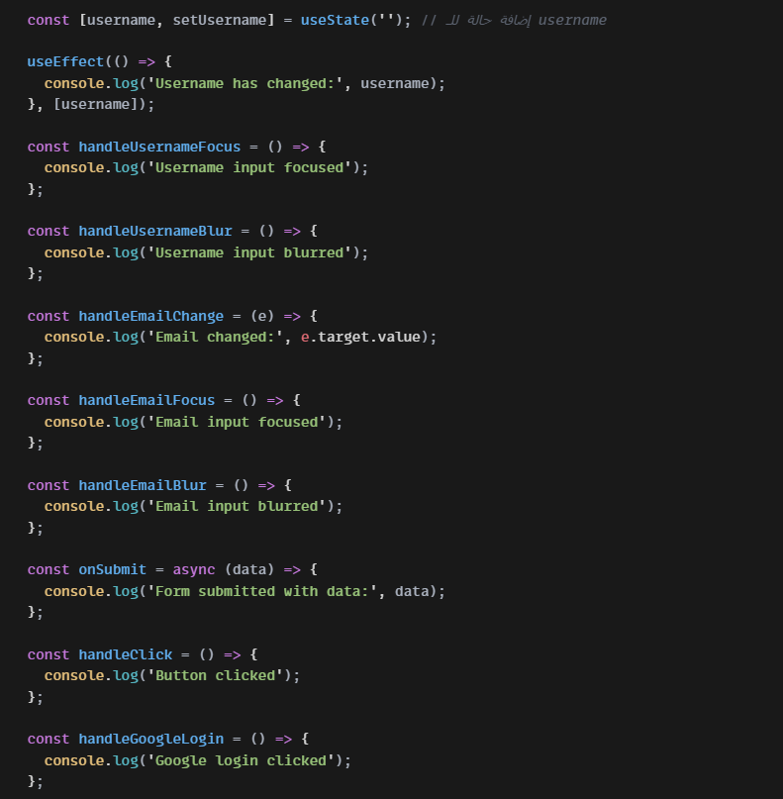

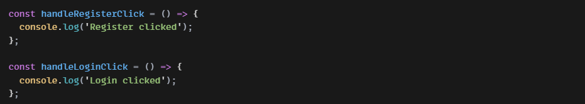

Figure 15:Sign Up Design Code(Frontend)

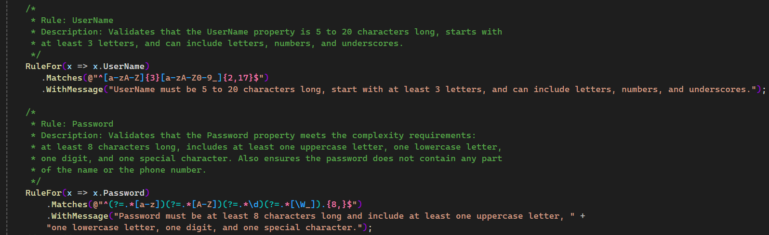

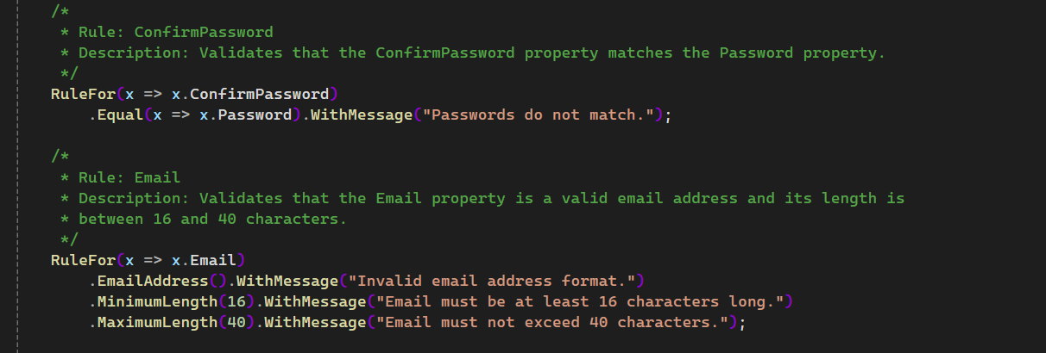

Figure 16: Sign Up Design Code(Backend)-A

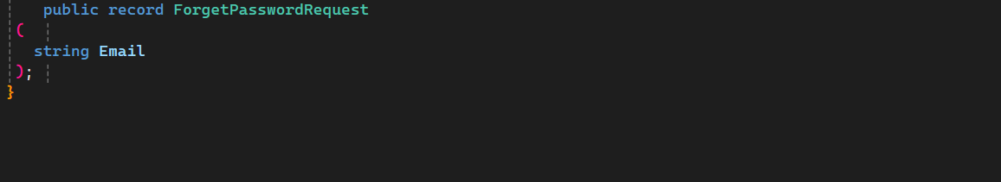

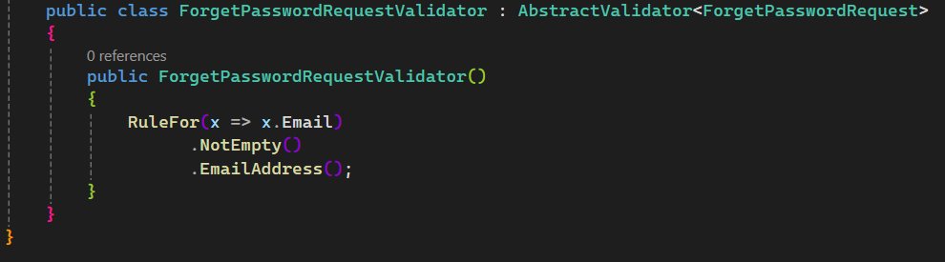

Figure 17:Sign Up Design Code(Backend)-B

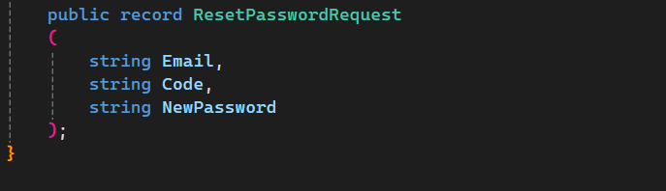

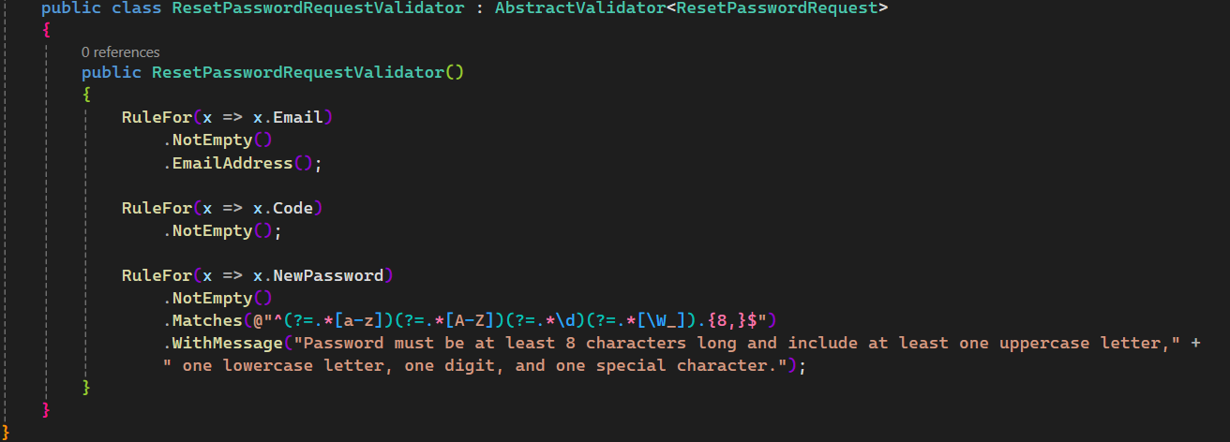

Figure 18:Sign Up Design Code(Backend)-C

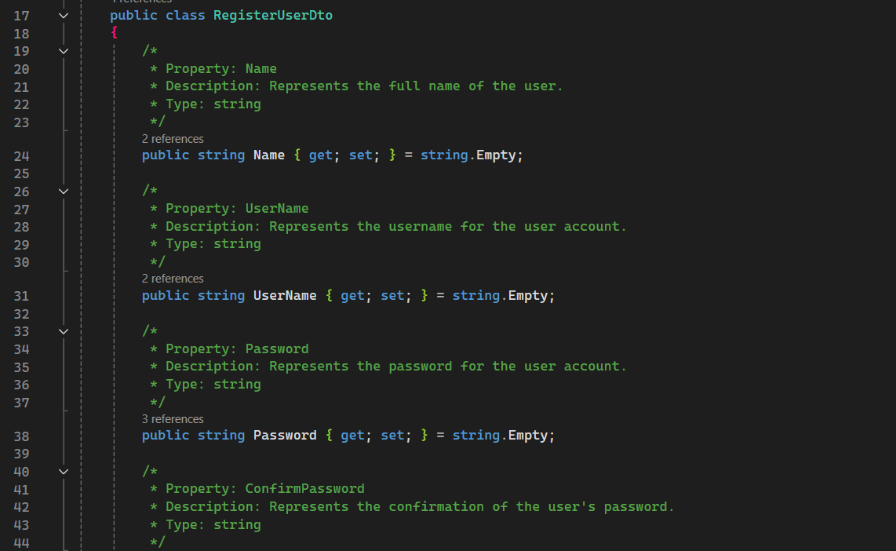

Figure 19:Sign Up Design Code(Backend)-C

**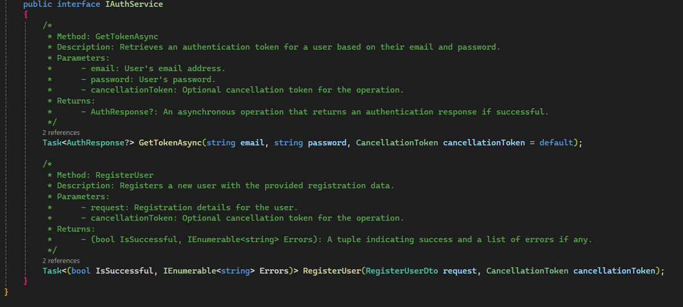  
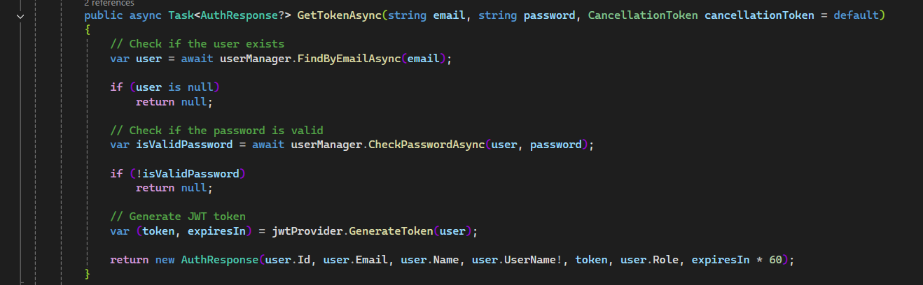**

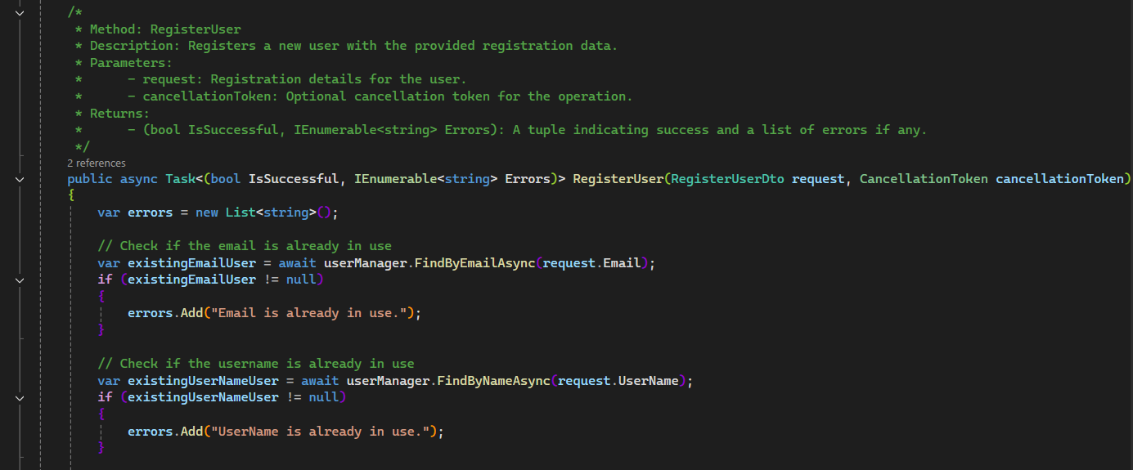

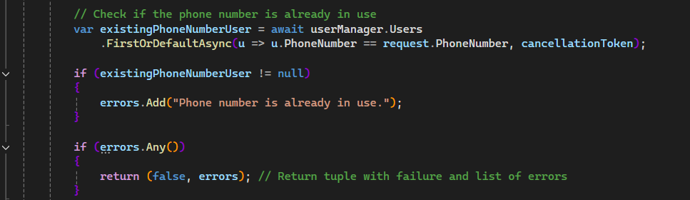

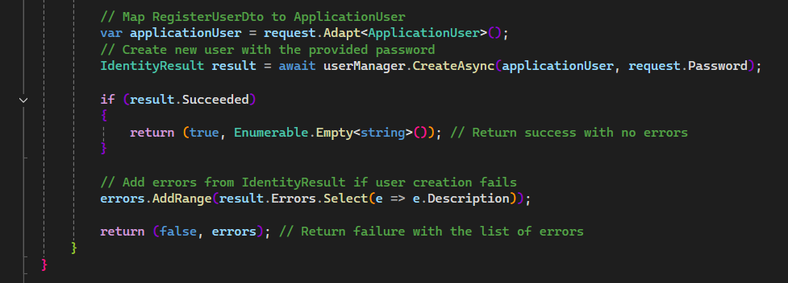

Figure 20:Sign Up Design Code(Backend)-D

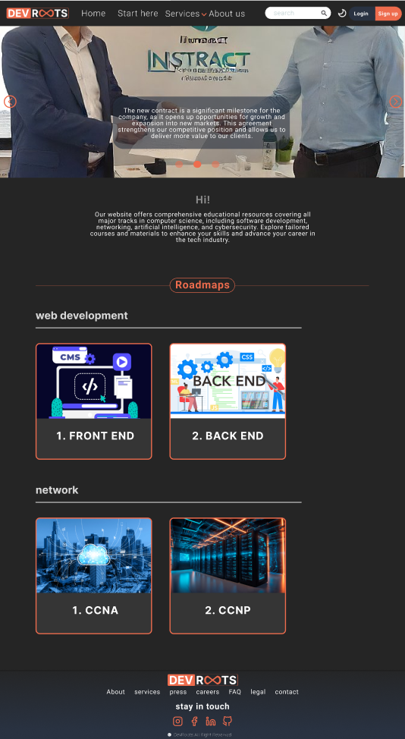

Figure 21: Home Page Dark Mode

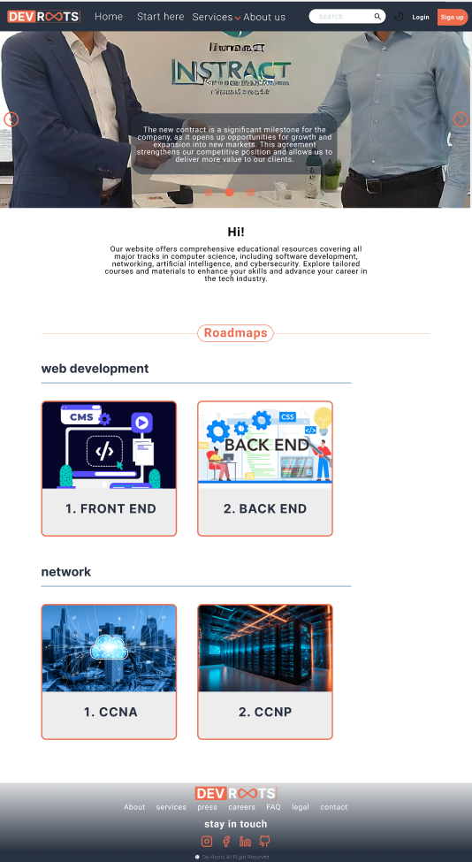

Figure 22: Home Page Light Mode

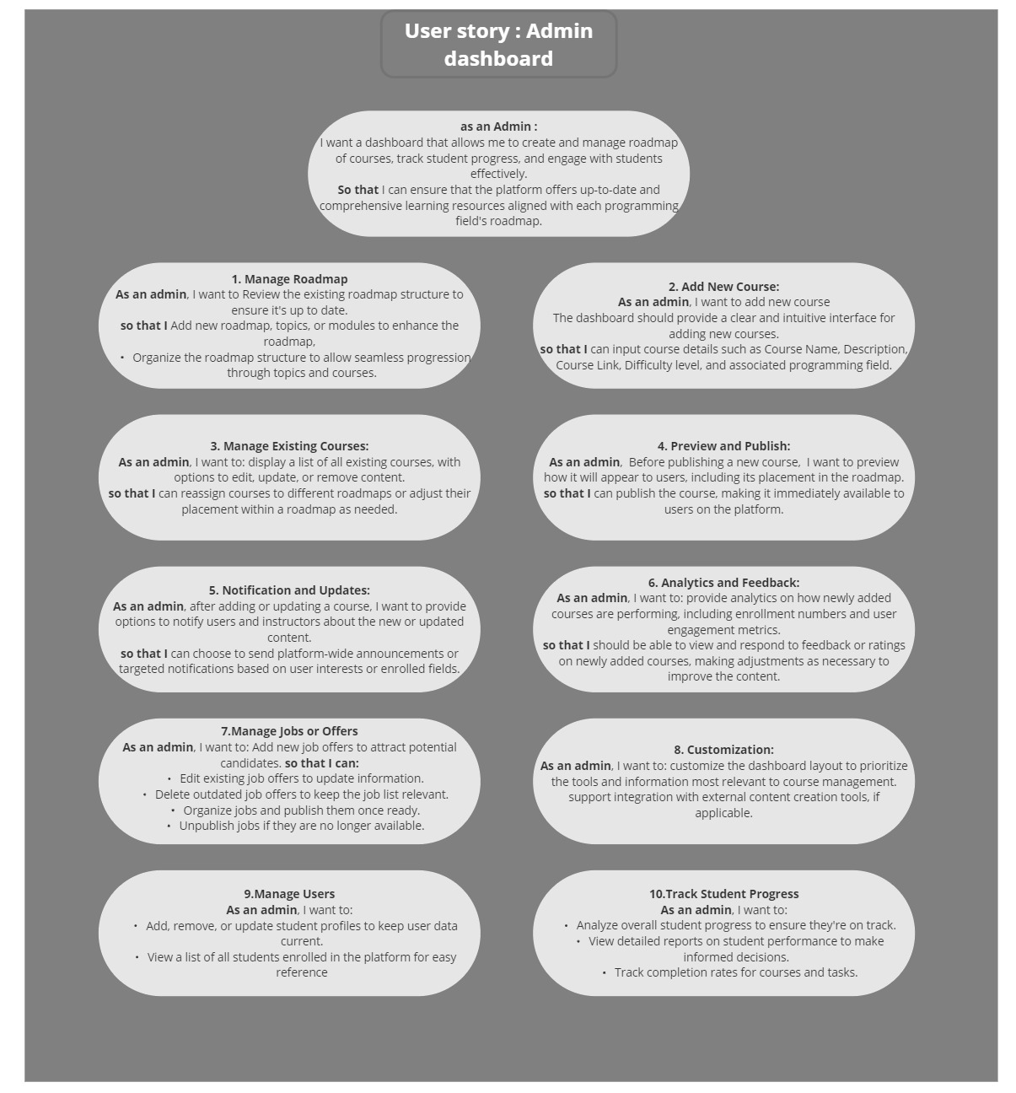

Figure 23:Admin Dashboard (User Story)

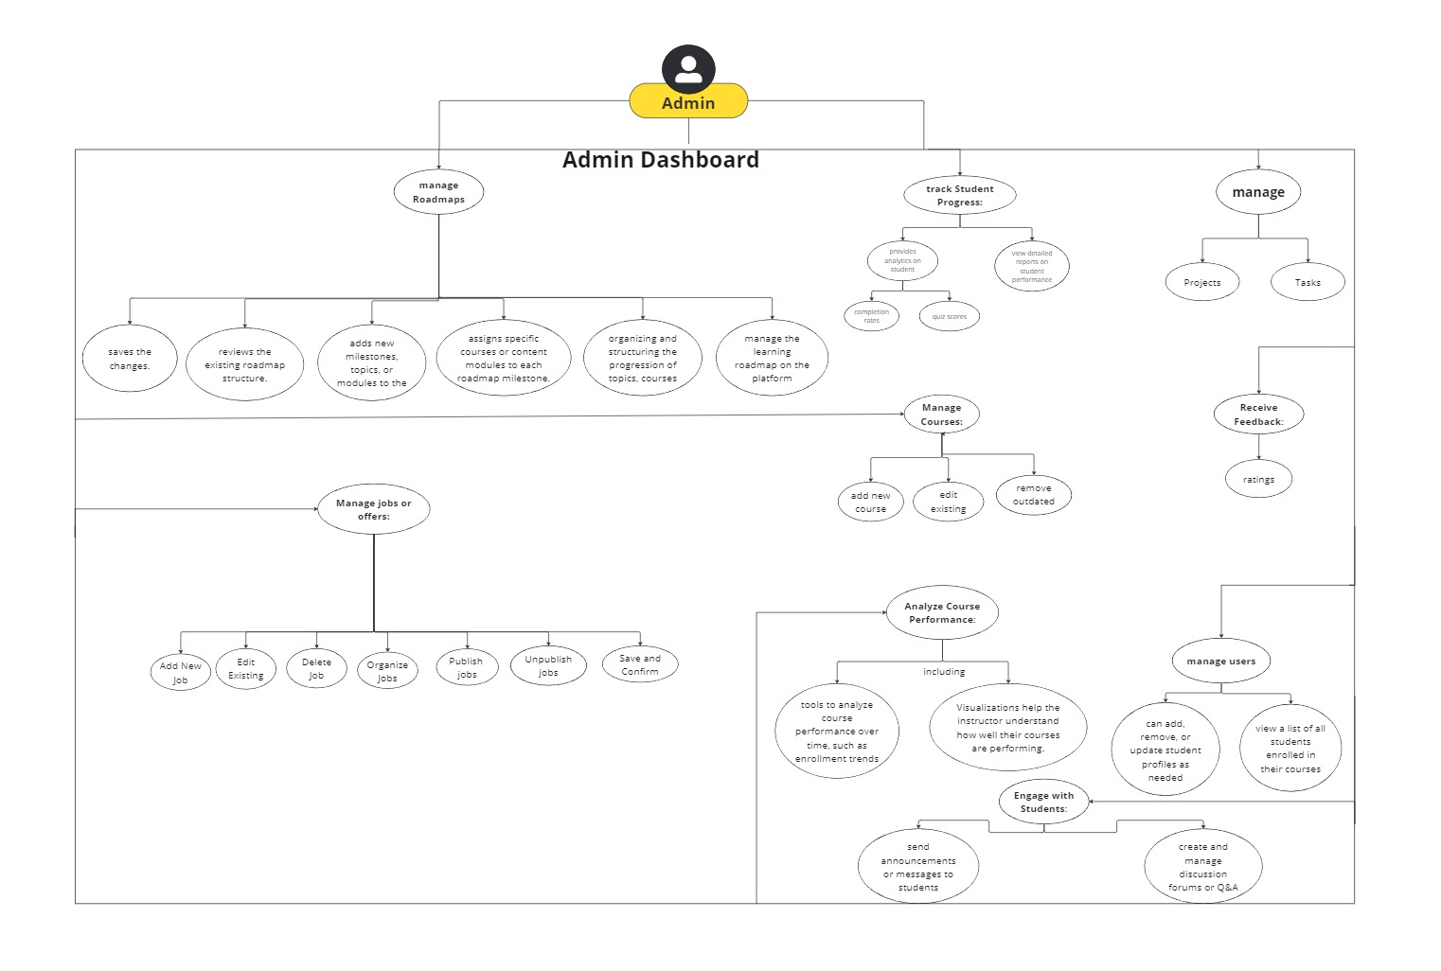

Figure 24:Admin Dashboard (Use Case)

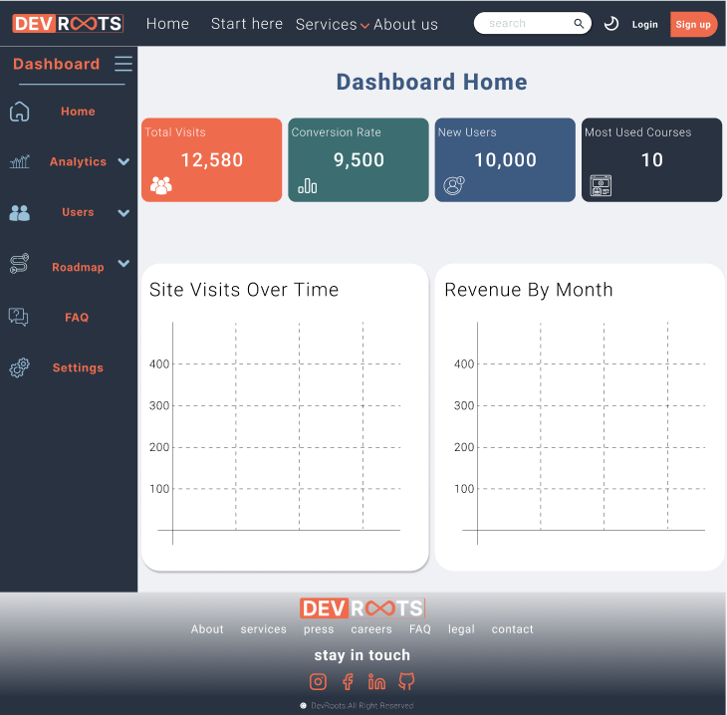

Figure 25:Dashboard Light Mode (UI)

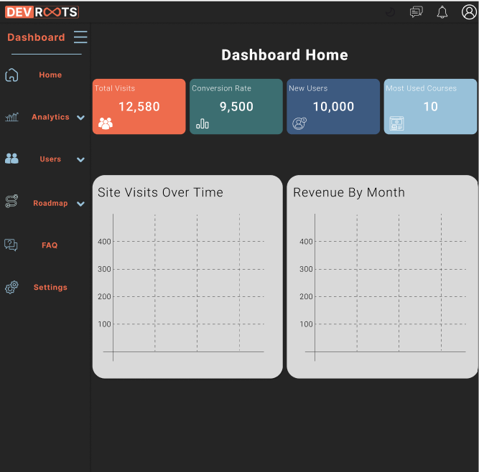

Figure 26:Dashboard Light Mode (UI)

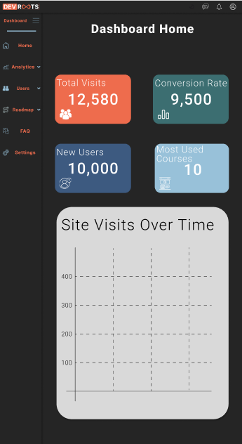 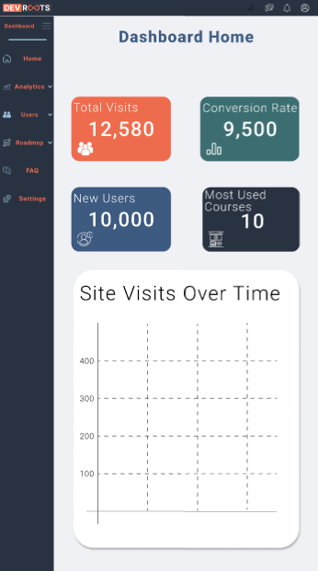

Figure 27:Dashboard home Light and dark Mode For Phone

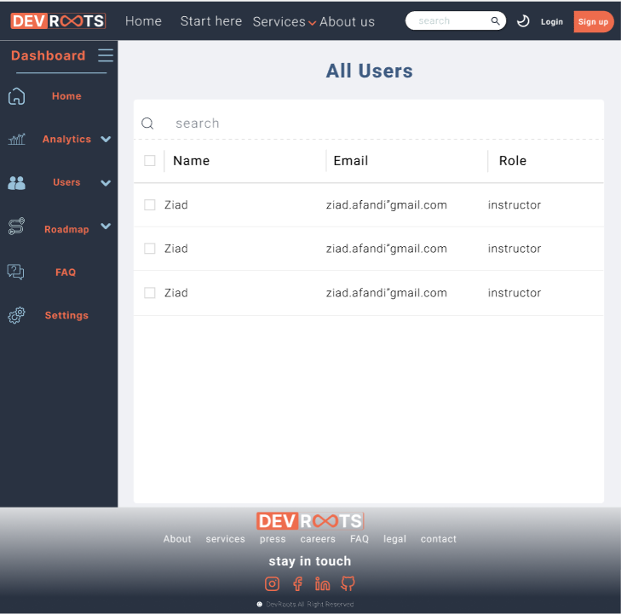

Figure 28:Dashboard All Users (UI)

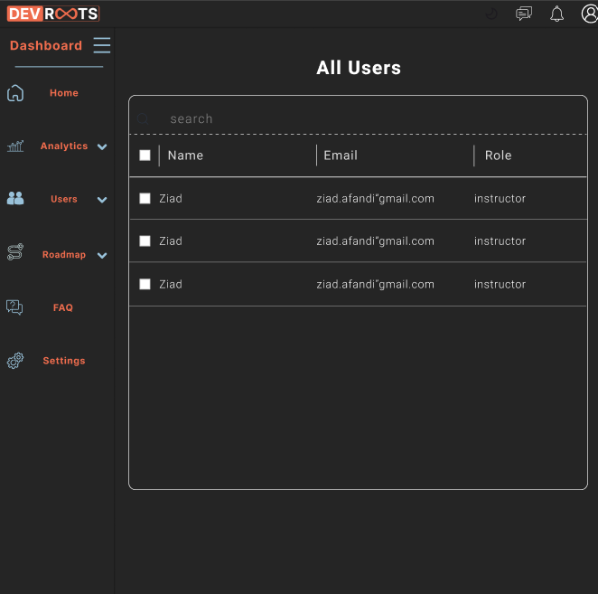

Figure 29:Dashboard All Users Dark mode (UI)

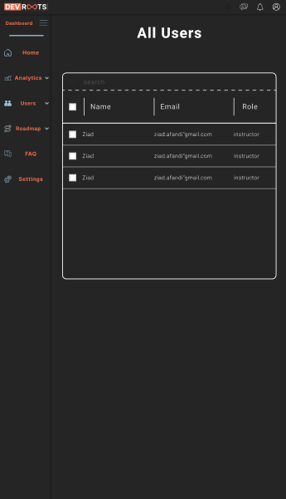 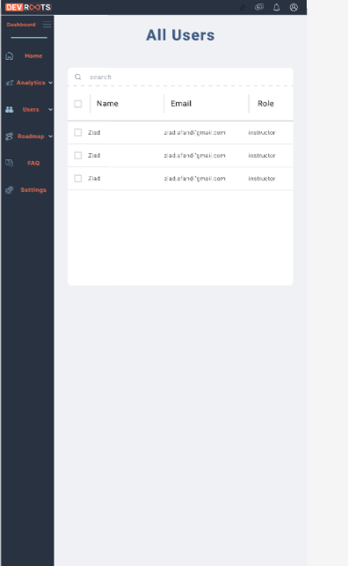

Figure 30:Dashboard All users Dark and light For Phone

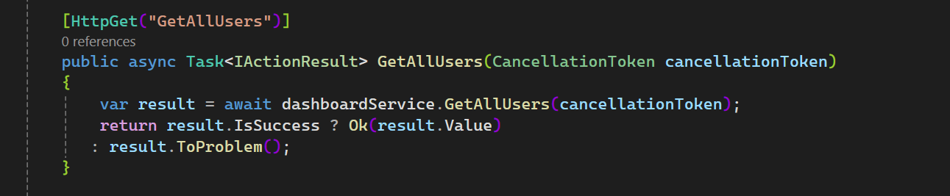

Figure 31:Dashboard Get All Users Design code (backend)

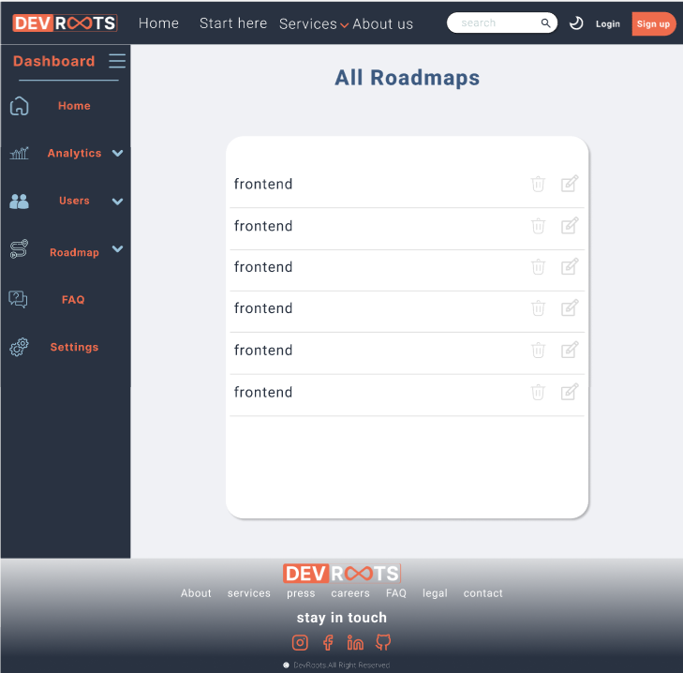

Figure 32:Dashboard All Roadmaps light mode (UI)

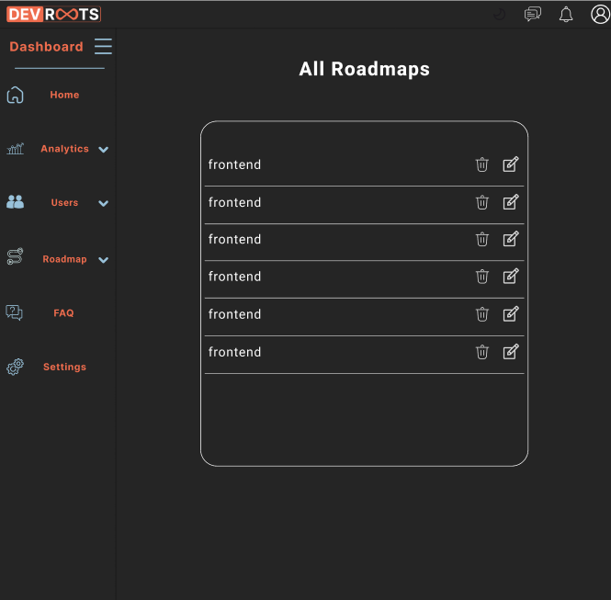

Figure 33: Dashboard All Roadmaps dark mode(UI)

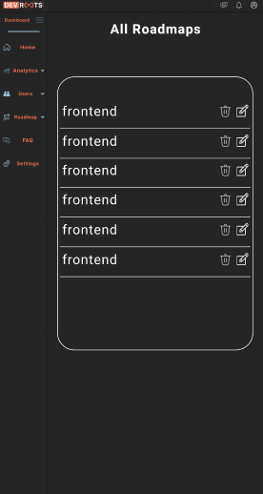 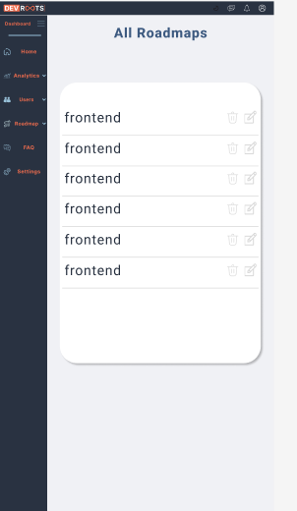

Figure 34: Dashboard All Roadmaps dark and Light mode for phone(UI)

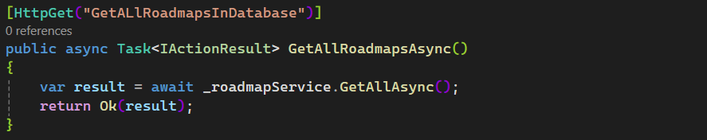

Figure 35:All Roadmaps Design Code (Backend)

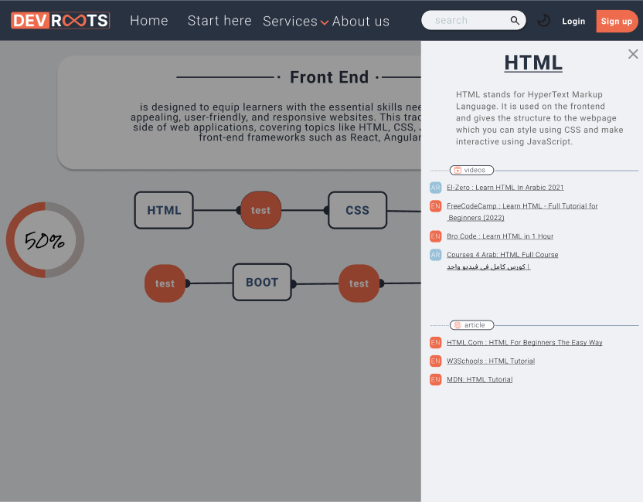

Figure 36:Links for courses in roadmap light mode

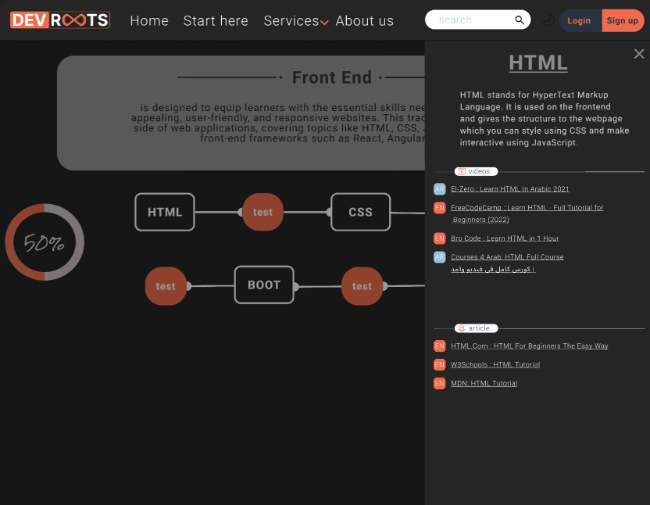

Figure 37:Links for courses in roadmap dark mode

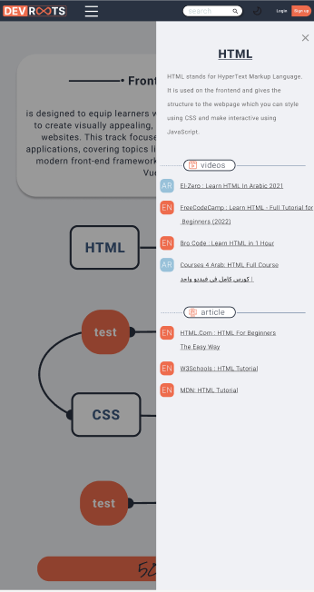 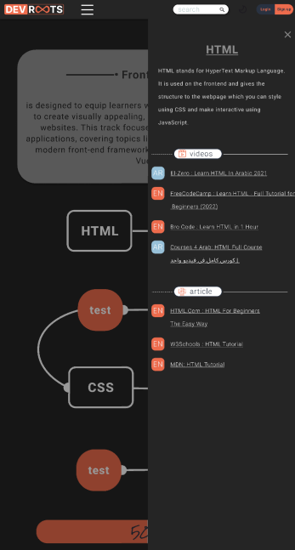

Figure 38:Links for courses in roadmap dark and light mode for phone

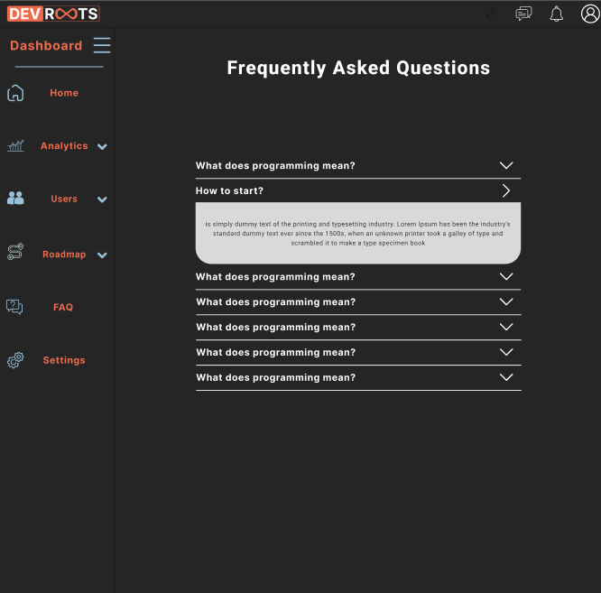

Figure 39:Dashboard for Questions Dark mode

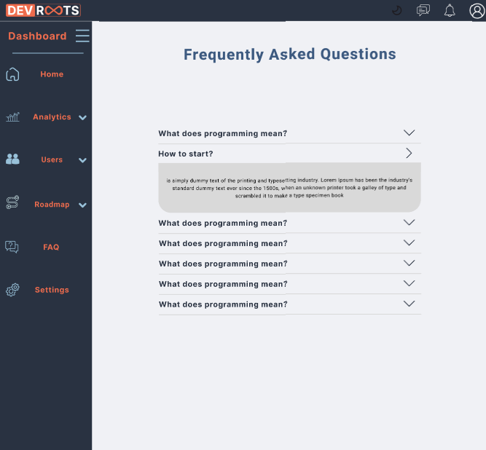

Figure 40:Dashboard for Questions Dark mode

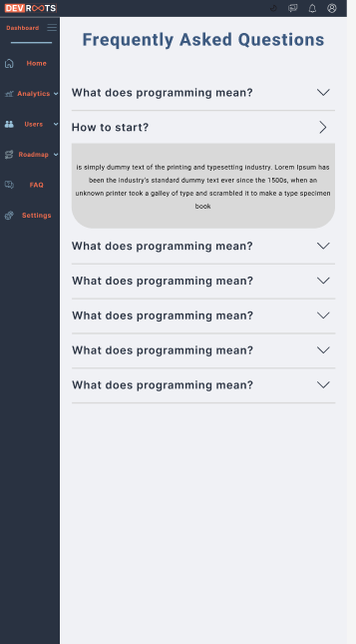 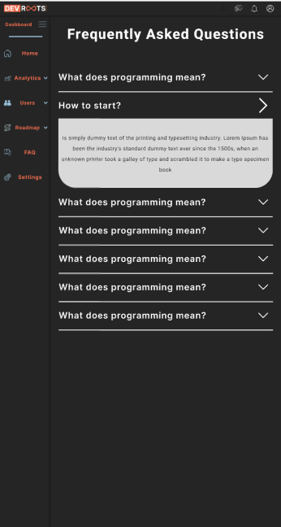

Figure 41:Dashboard for Questions Dark mode and light mode for phone

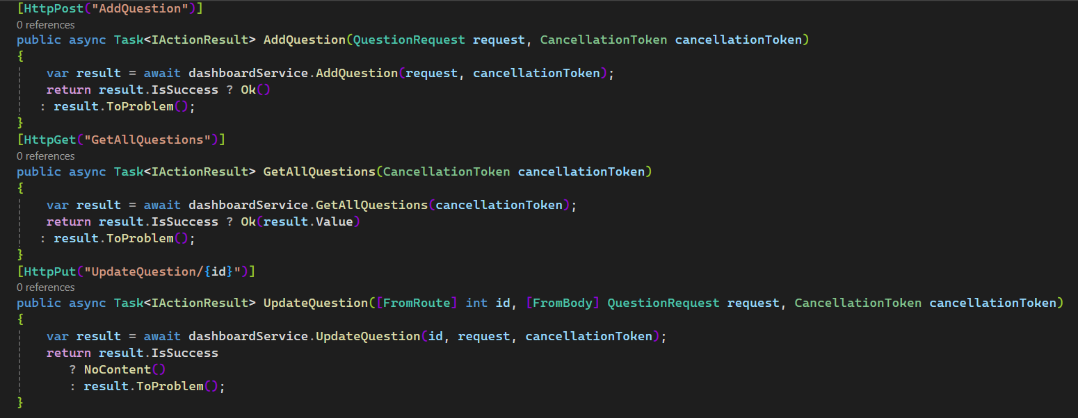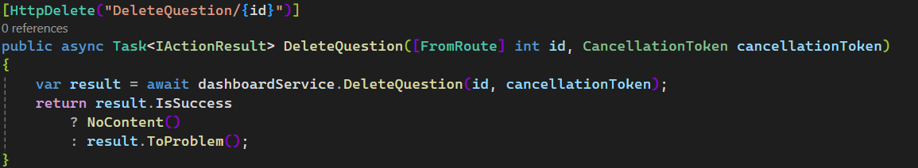

Figure 42:Questions in Dashboard Design Code (Backend)

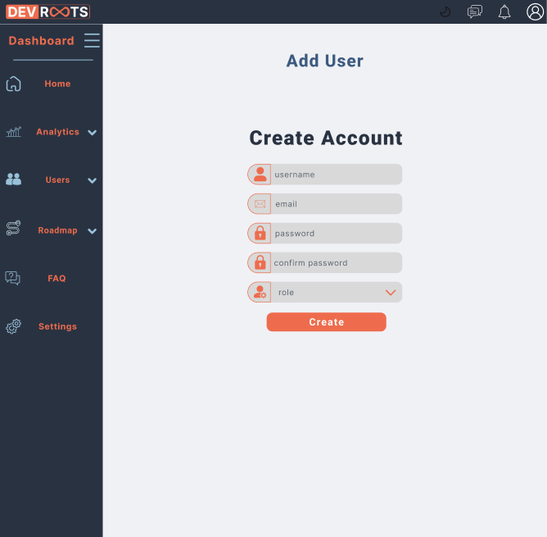

Figure 43: Dashboard Add User Light mode (UI)

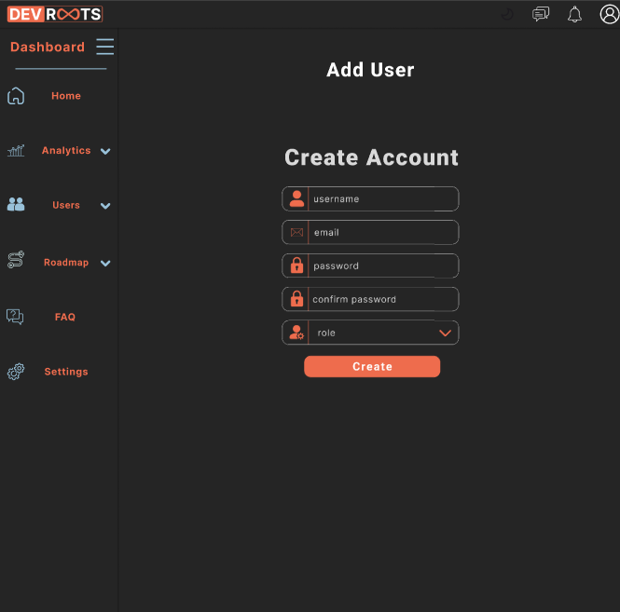

Figure 44: Dashboard Add User Light mode (UI)

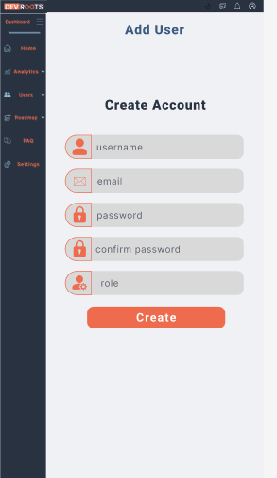 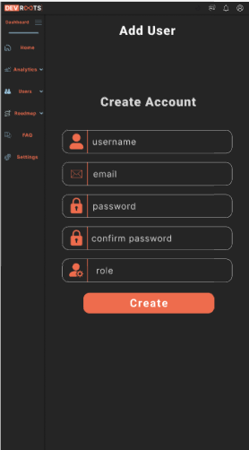

Figure 45: Dashboard Add User Light mode and dark mode for phone (UI)

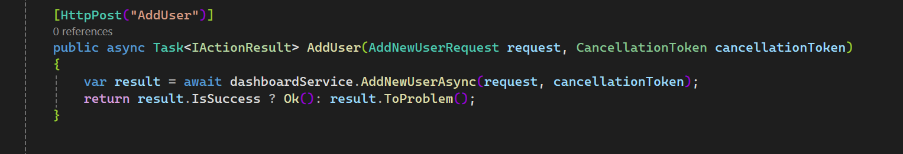

Figure 46:Dashboard Add User Design Code

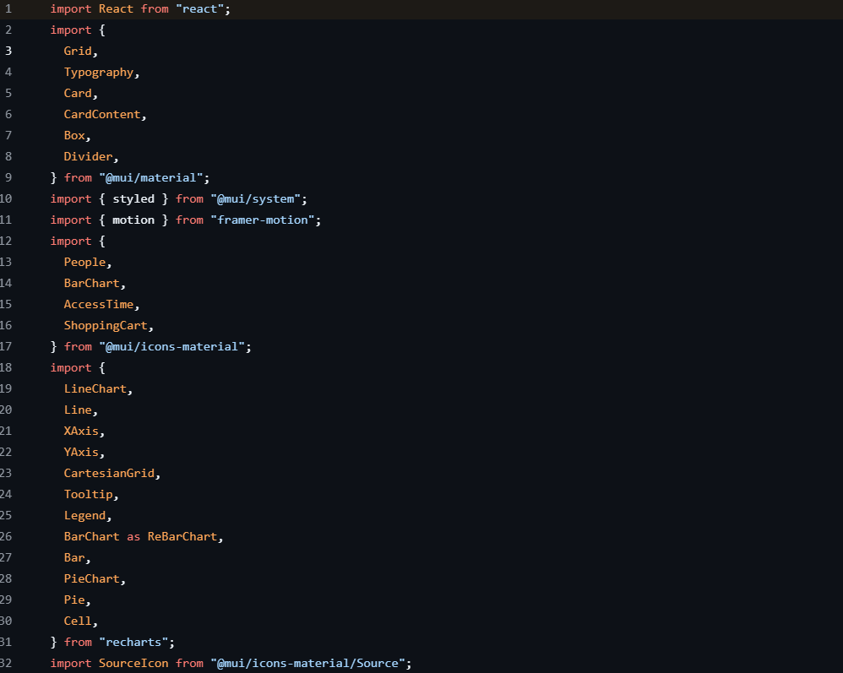

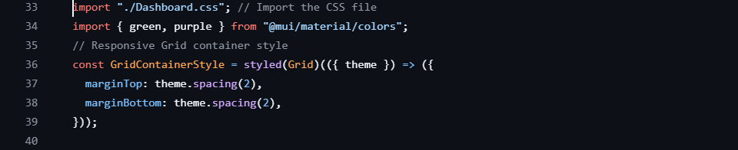

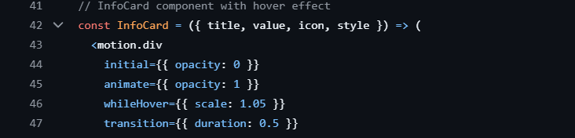

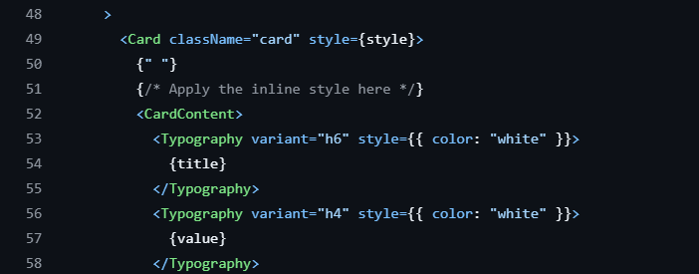

Figure 47: Dashboard Code (Frontend)-A

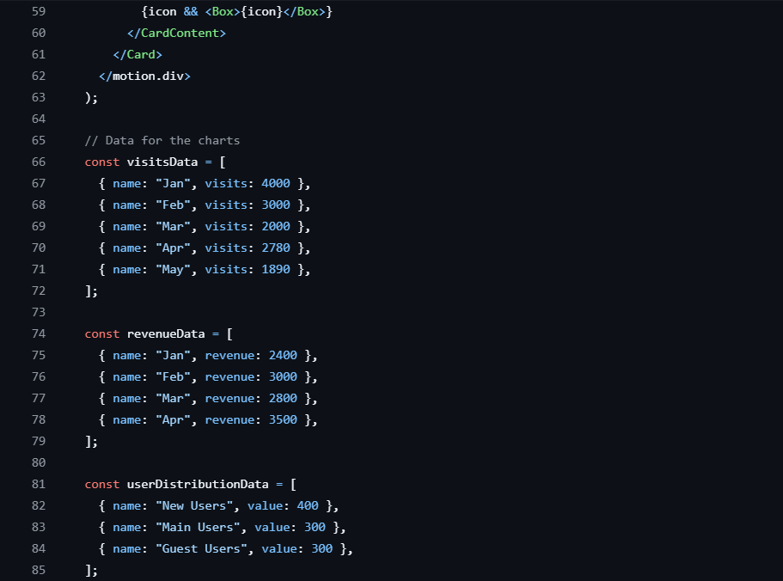

Figure 48:Dashboard Code (Frontend)-B

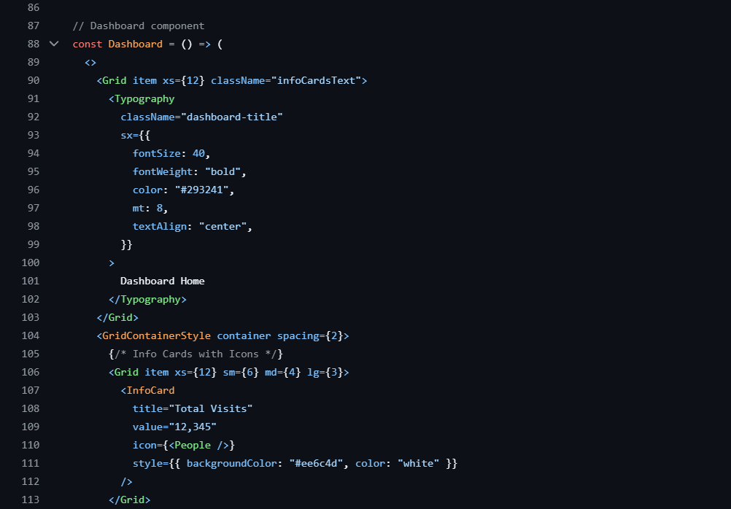

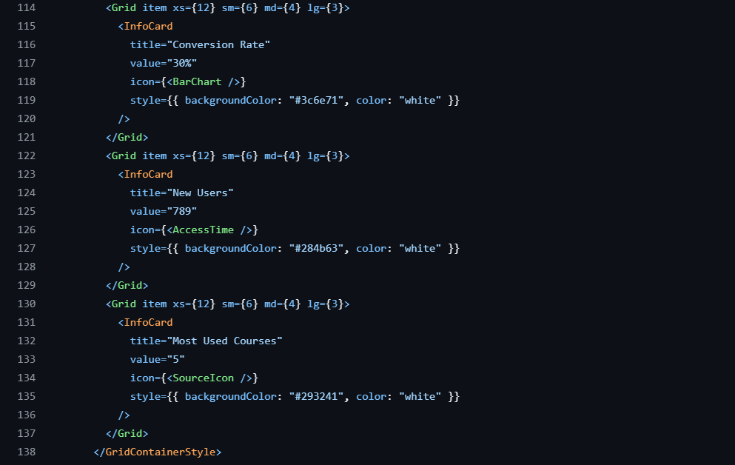

Figure 49:Dashboard Code (Frontend)-C

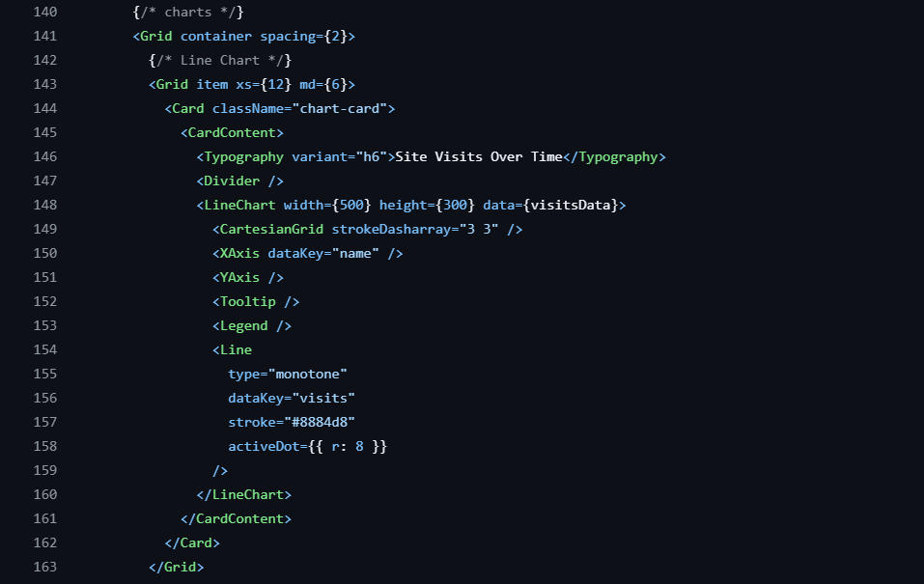



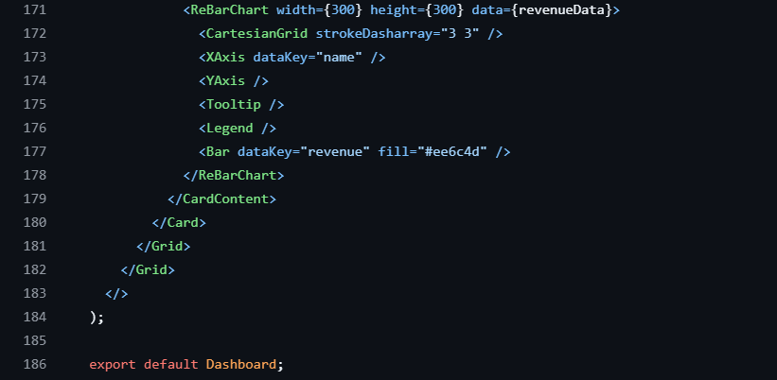

Figure 50:Dashboard Code (Frontend)-D

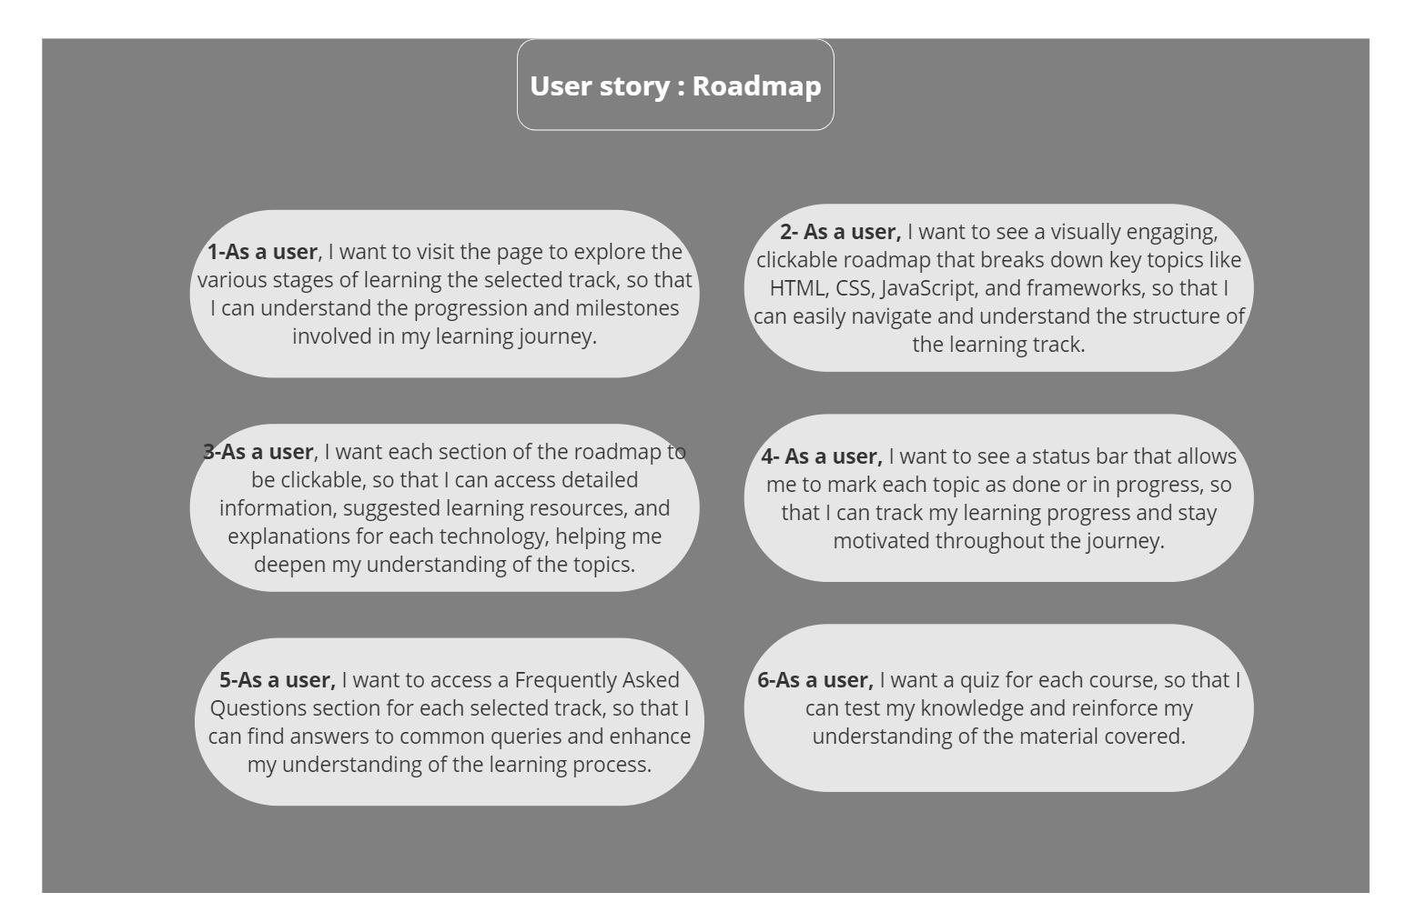

Figure 51:Roadmap Design (User Story)

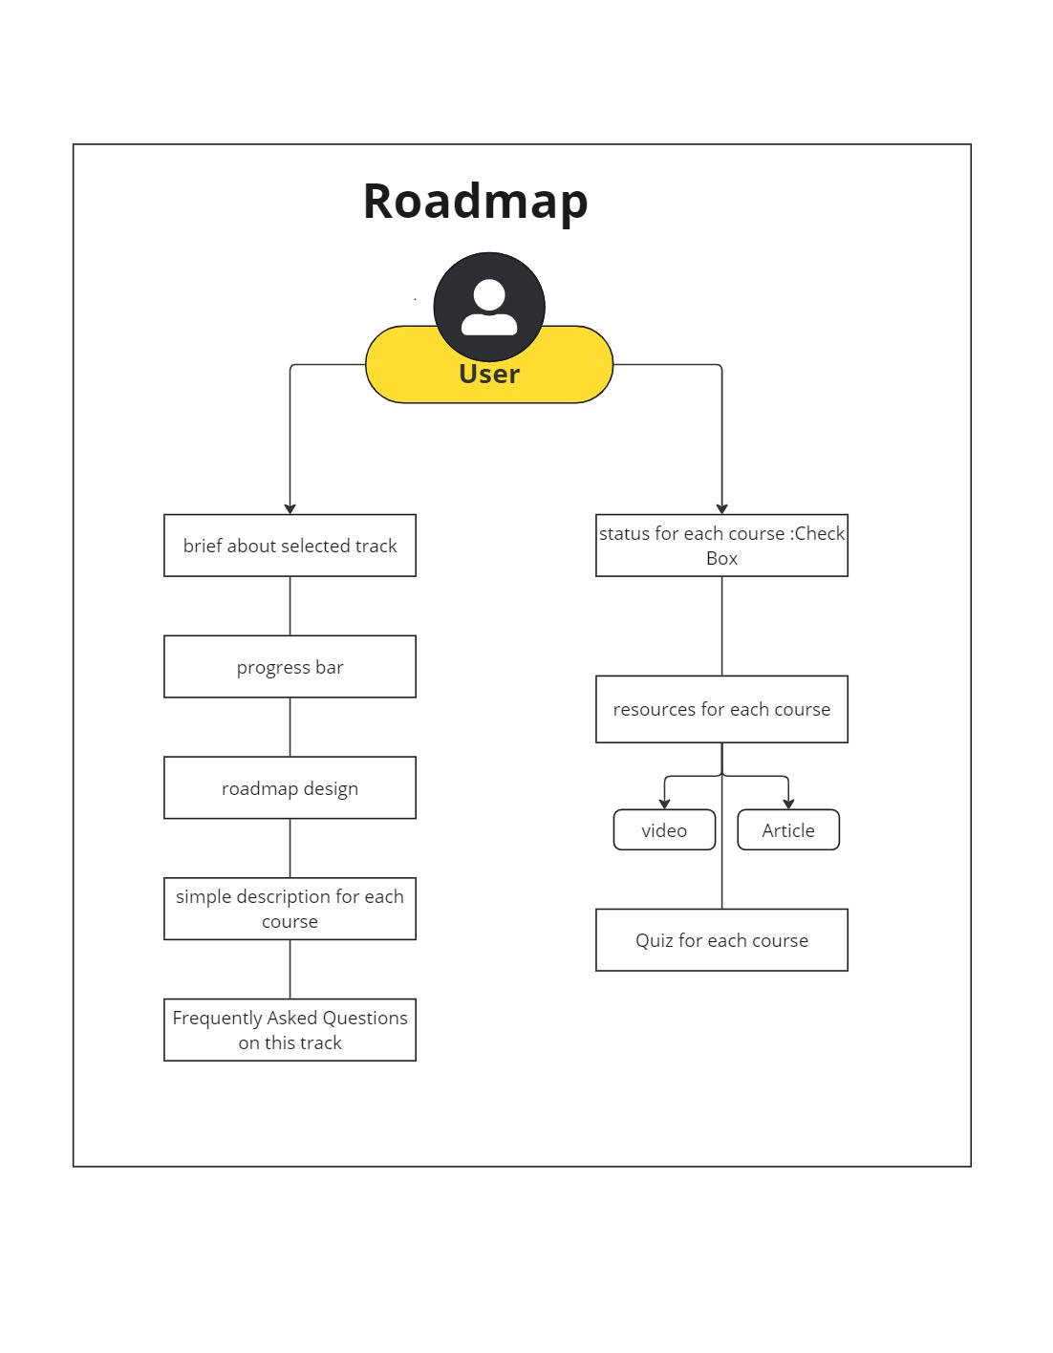

Figure 52:Roadmap Design (Use Case)

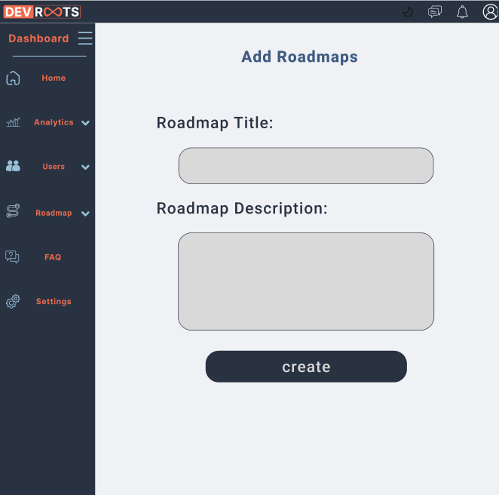

Figure 53:Add Roadmap Light Mode(UI)

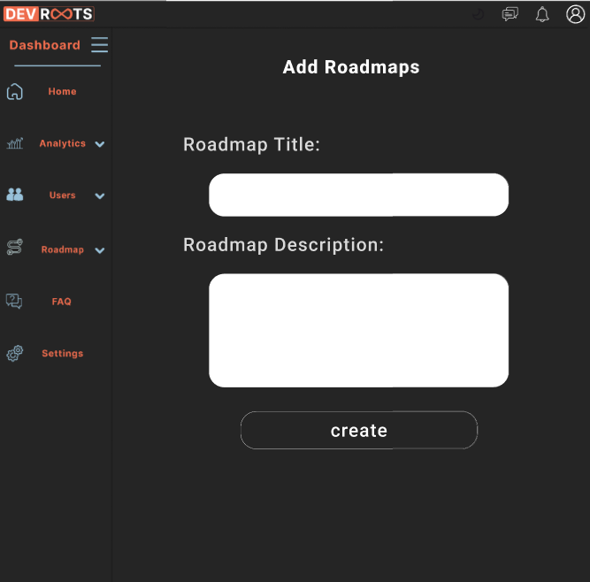

Figure 54:Add Roadmap dark Mode(UI)

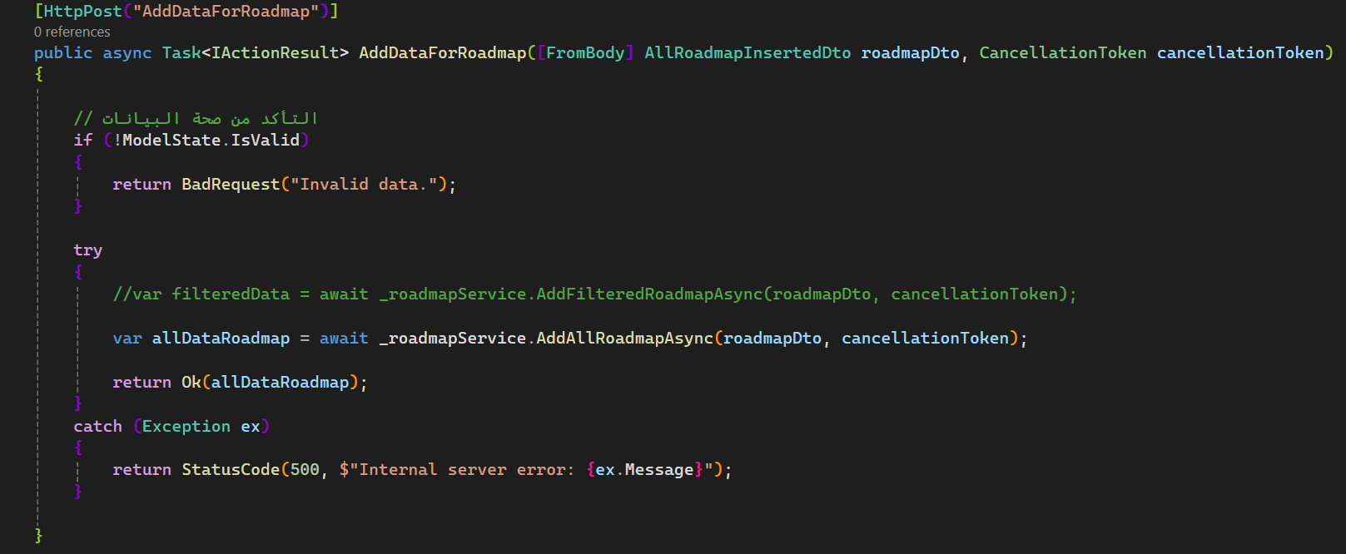

Figure 55:Add Roadmap Design code(backend)

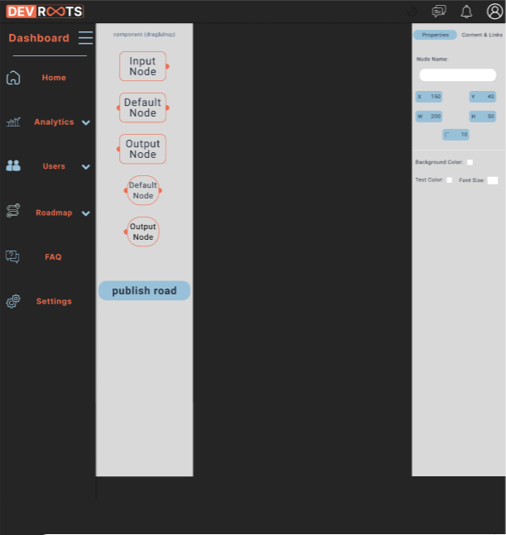

Figure 56:Dashboard Add Roadmaps properties Dark Mode

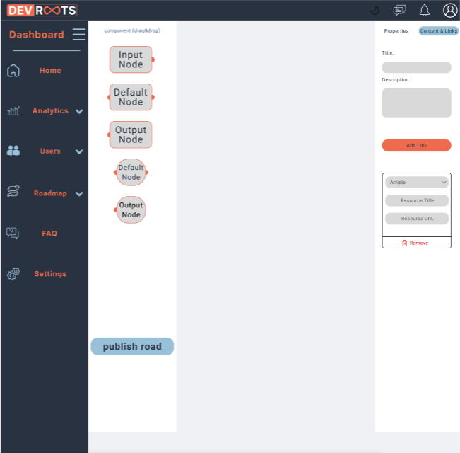

Figure 57:Dashboard Add Roadmaps content & links Light Mode

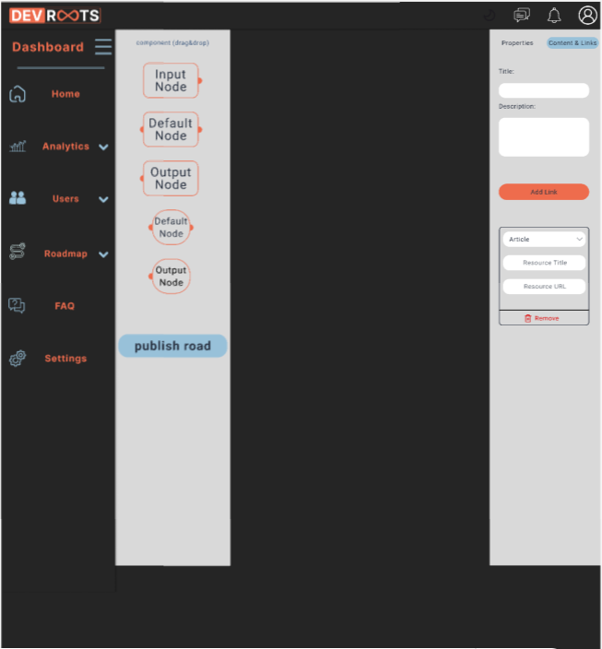

Figure 58:Dashboard Add Roadmaps content & links Dark Mode

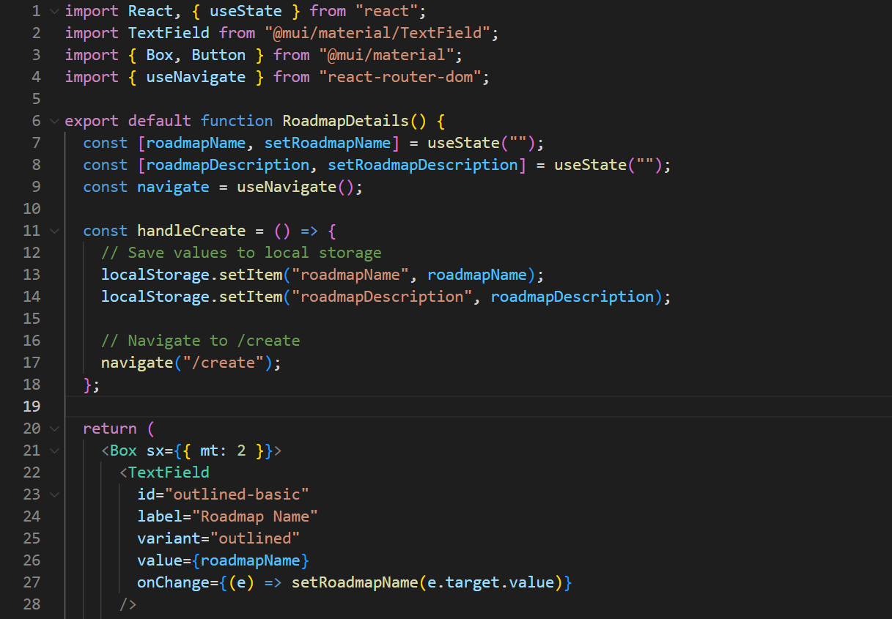

Figure 59:Add Roadmap Design Code (Frontend)-A

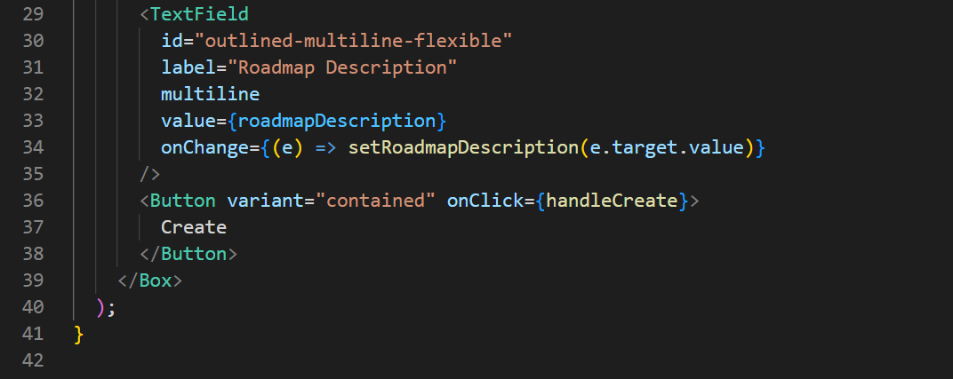

Figure 60:Add Roadmap Design Code (Frontend)-B

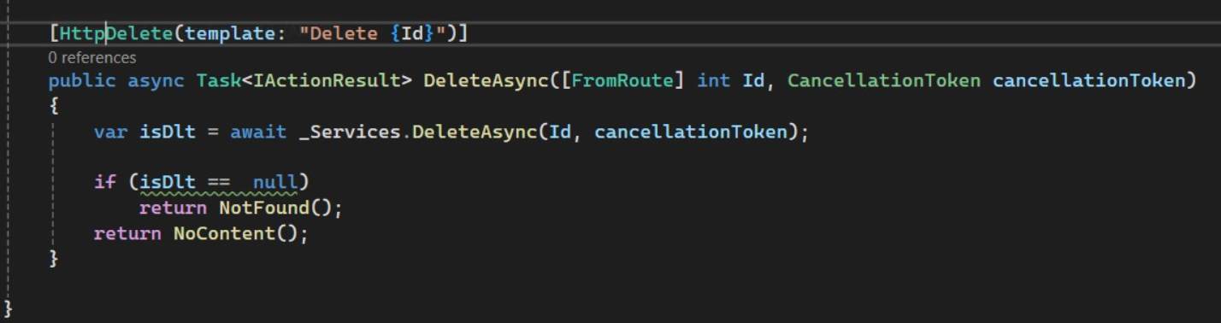

Figure 61:Roadmap Design Code (Backend)

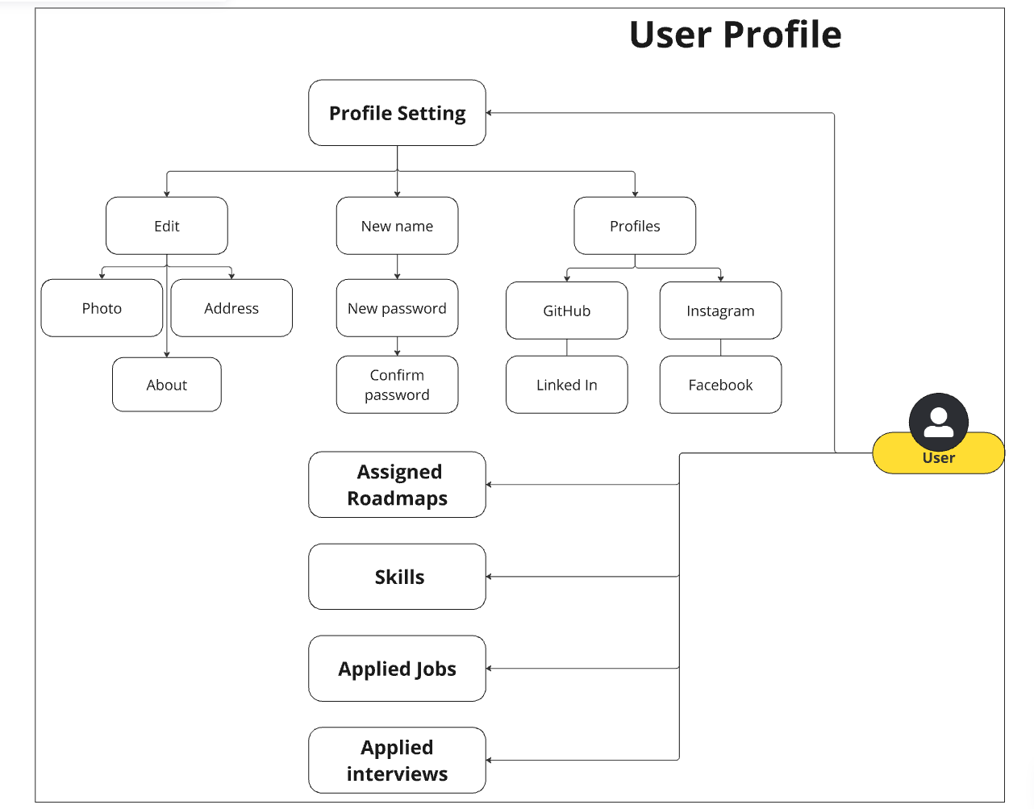

Figure 62:User Profile (Use Case)

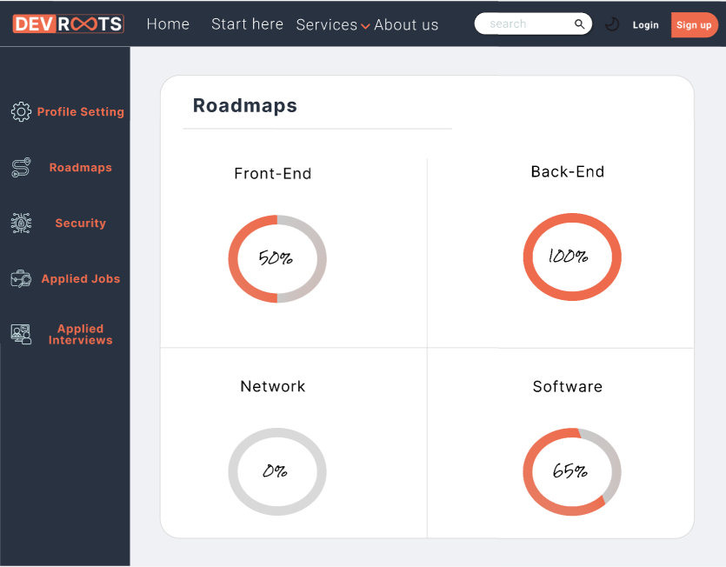

Figure 63:Profile Roadmap (UI)

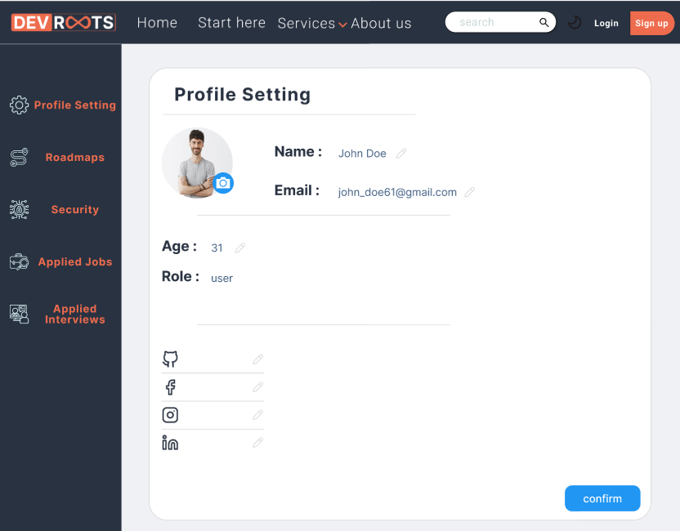

Figure 64:Profile Setting Design (UI)

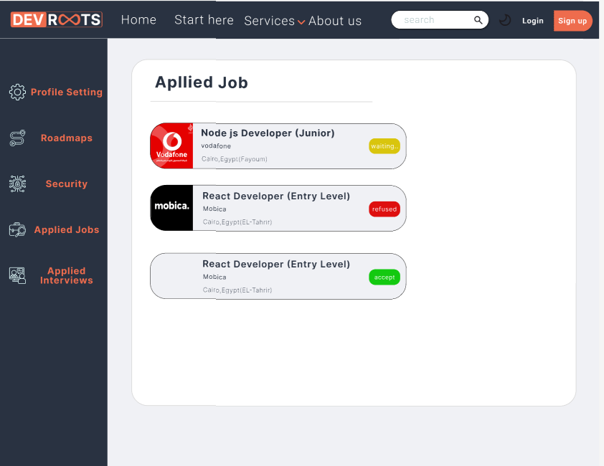

Figure 65:Applied Job(UI)

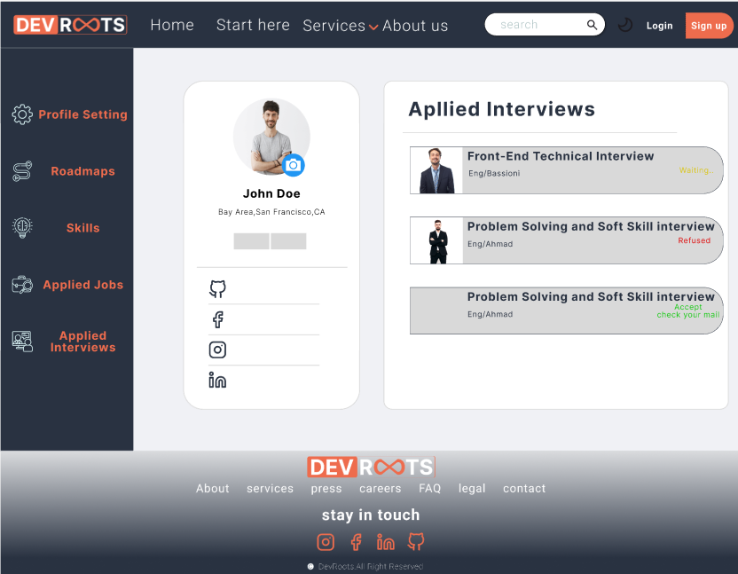

Figure 66:InterView(UI)

Chapter Four

Tools & Dependences

